Cover

The State of the Heartland:
Factbook 2018

Metropolitan Policy Program at Brookings
Walton Family Foundation

October 2018

www.theHeartlandSummit.org

Title page

The State of the Heartland:
Factbook 2018

Mark Muro, Jacob Whiton, Robert Maxim
Ross DeVol

Metropolitan Policy Program at Brookings
Walton Family Foundation

October, 2018

Executive Summary
Two years after a national election that experts say pitted the “American Heartland” against the rest of the nation, pinning the region down has only gotten trickier.
In fact, the proliferation of “red vs. blue” maps and apocalyptic talk-show punditry has if anything made it harder for the region to get a clear sense of itself and how it is doing.
Instead, the national debate purveys conflicting, distorted images that often portray the region either as a vast “flyover” interior where jobs have disappeared and anger is pervasive, or else as an idyllic expanse of wheat fields, reviving factories, and mid-sized cities filled with start-ups.
To be sure, some of the social media “hot takes” and journalistic quick hits have their truth, and even their use. But what Heartland changemakers really need now is a more clarifying look at the region. Such a chronicle—by the numbers, with an agreed-upon geography—might actually help in promoting understanding and bringing the conversation home.
Which is the point of this factbook: Prepared to support the Walton Family Foundation’s inaugural Heartland Summit, the State of the Heartland: Factbook 2018 is intended to help Heartland leaders and citizens get on the same page about the region’s current condition and its trajectory at a crucial time.
To that end, this factbook adopts a new state-based definition of the region developed by the Walton Family Foundation (WFF) and then provides a series of 26 socioeconomic measures focused on how the defined region’s economy has been performing since the recent financial crisis. The geography employed consists of 19 inland states. The indicators, meanwhile, presume the fundamental importance of economic vitality to regional, social, and cultural health. As such, the factbook’s indicators first cover nine aspects of the region’s topline outcomes in the search for growth, prosperity, and inclusion. After that, 17 indicators are used to benchmark the region’s standing on four sorts of drivers of strong outcomes.
What do the indicators say about the region? Three major takeaways emerge clearly from the analysis:
- The Heartland economy is doing better than is sometimes portrayed. Growth measured by job and output growth have been steady, if not stellar, since 2010 with 19 of the 19 Heartland states adding jobs and 18 increasing their output. Prosperity has also been slowly rising as all 19 states enjoyed increased standards of living, all 19 posted increases in the average wage, and 12 saw productivity increases. Supporting all of this, meanwhile, is an impressive base of crown jewel export industries, in particular strong concentrations of advanced manufacturing in the eastern Heartland and of agribusiness in the western Heartland. Overall, the 19 Heartland states constitute a manufacturing super-region and export powerhouse that outperforms the rest of the country on a number of core economic indicators.

- The Heartland, however, is not monolithic: Its economy varies widely across place. In this regard, the region is a checkerboard of sub-regions, states, and local communities where some Heartland places are thriving while others are deteriorating—just as in other regions. On multiple measures, for instance, a stark gap exists between the performance of the western Heartland and the eastern one. Labor force participation, for example, remains at crisis levels in the eastern section, while to the west labor markets are some of the tightest in the nation. Similar divides run north to south. For example, while most Northern states reside in the top half of states on measures of human capital and innovation most Southern ones reside among the bottom 10. Likewise, when looking at Heartland sub-regions, the Plains in general is performing quite well, while areas such as the Black Belt (running through Louisiana, Mississippi, and Alabama), Appalachia, and Indian Country struggle with an emergency of elevated poverty (shared by minorities throughout the region) and high rates of obesity and addiction. Additionally, Heartland metropolitan areas are doing better in general than the region’s rural areas. While large and medium-sized metro areas in the region grew slightly, small towns and rural areas lost population.

- Serious deficits in the region’s human capital and innovation capacity pose the most serious challenges to improving future prosperity. On this front the factbook’s indicators depict a region that is—in most places—struggling to amass the human and technology capacity needed to support broad-based prosperity. Regarding the region’s stocks of human capital, only the Dakotas added population as fast as the rest of the nation, meaning that slow population growth—including among prized young workers—limits the region’s overall growth prospects. Worse, only three Heartland states exceeded the average B.A. attainment for the rest of the country, meaning that most places and populations in the region may be unprepared for an increasingly digitalized labor market. Turning to the region’s innovation assets, weak R&D flows, a thin roster of top universities for tech transfer, and a near-complete dearth of venture capital (VC) investment outside Chicago leave Heartland firms starved of the new ideas, new practices, and funding leveraged by firms elsewhere to drive competitive breakthroughs. Finally, lower levels of urban dynamism and epidemics of obesity and opioid use represent substantial drags on productivity and output. In sum, these deficits represent the most challenging findings of the fact book and pose the greatest hurdles to changemakers.

What do these findings suggest for future discussion and action? Above all, the starkness of the region’s human capital and innovation challenges underscores that strategies to increase the region’s education levels and expand its innovation activities should be top-of-mind when Heartland leaders gather to talk about the Heartland’s future. The reason for this is clear: The human and innovation capacities of places are now the core drivers of long-term performance. Or as the Walton Family Foundation’s Ross DeVol notes, the states and regions that build human capacity and invest in and nurture innovation will establish ecosystems that create high-quality, broadly shared growth for their citizens while attracting migrants from elsewhere, boosting growth further.

The good news is that even in its most challenging areas for improvement the Heartland boasts some of the most impressive and impactful collaborations anywhere of business, civic, and government changemakers working together to solve problems. And so the Heartland’s leaders should survey it all, assess what’s working, and get to work.

Notwithstanding its many challenges, the Heartland is large, varied, and full of communities already hard at work. These places are learning what’s real, making big plans, and putting them in motion to make the Heartland better. In all of that there is surely grist for unlocking the Heartland’s full potential—and in doing so unleashing America’s.

The state of the Heartland: benchmarking outcomes and drivers
Outcomes | Current |  | Change
 | Heartland | Non-Heartland | Heartland | Non-Heartland
Growth
Jobs | 44,378,000 | 99,483,000 | 1.3% | 1.9%
Output (Mil.) | $4,905,000 | $12,802,000 | 1.4% | 1.9%
Jobs at young firms | 3,297,000 | 9,341,000 | -0.3% | 0.4%
Prosperity
Productivity | $111,000 | $131,000 | 0.1% | 0.0%
Average wage | $48,000 | $49,000 | 1.0% | 0.8%
Standard of living | $50,000 | $57,000 | 1.1% | 0.9%
Inclusion
Employment rate | 72.8% | 72.4% | 3.2% | 3.4%
Median wage | $30,000 | $28,000 | 0.6% | -0.4%
Poverty rate | 14.6% | 13.8% | -1.2% | -1.3%
Drivers | Current |  | Change
 | Heartland | Non-Heartland | Heartland | Non-Heartland
Tradeable Industries
Adv. industries (employment share) | 9.8% | 9.5% | 2.5% | 0.6%
Exports (share of GDP) | 12.3% | 9.6% | 1.8% | 2.3%
Agriculture (output) | $225,609,000 | $187,628,000 | 1.2% | 0.5%
Energy (bn BTU) | 21,300 | 47,700 | 2.0% | 2.6%
Human Capital
Population | 98,828,000 | 226,891,000 | 0.3% | 0.9%
Young adult population | 21,998,000 | 49,870,000 | 0.4% | 1.2%
Bachelor's degree attainment | 28.1% | 32.6% | 2.9% | 3.1%
Racial degree gap (black-white attainment gap) | 58.5% | 59.3% | N/A | N/A
Adult obesity | 32.5% | 28.2% | 2.8% | 1.8%
Opioid prescription rate (per 100 residents) | 81.0 | 60.2 | -2.9% | -3.4%
Innovation
R&D spending (% of GDP) | 2.0% | 2.9% | 0.9% | 3.2%
University tech transfer rankings | 25 | 75 | N/A | N/A
Venture capital spending (% of total) | 5.2% | 94.8% | -5.8% | 5.9%
Metro area econ activity (large metro) | $124,000 | $145,000 | 0.1% | 0.1%
Infrastructure
Growth by community (large metros) | 75.4% | 90.4% | 2.0% | 0.8%
Housing values | $135,000 | $215,000 | 0.2% | 1.5%
Broadband access (% without) | 6.6% | 3.4% | N/A | N/A
Source: Brookings Institution / Walton Family Foundation “The State of the Heartland: Factbook 2018”
Note: Blue and red shading indicates positive or negative distance from the non-Heartland average, respectively.
Contents
Introduction 11
Sidebar: “A Country Within the Country:” Defining the American Heartland 14
The State of the Heartland: Indicators 16
The State of the Heartland: Factbook 2018 23
Outcomes 24
Growth 25
- Jobs 26
- Output 29
- Jobs at young firms 31
Prosperity 33
- Productivity 34
- Average wage 37
- Standard of living 39
Inclusion 41
- Employment rate 42
- Median wage 44
- Poverty rate 46
Drivers 51
Tradeable industries 52
- Advanced industries 53
- Exports 56
- Agriculture 58
- Energy 60
Human capital 62
- Population 63
- Young adult population 65
- Bachelor’s degree attainment 68
- Racial bachelor’s degree gap 70
- Adult obesity 72
- Opioid prescription rate 74
Innovation 76
- R&D spending 77
- University technology transfer rankings 79
- Venture capital spending 81
- Sidebar: Indexing the Heartland’s Position in the Innovation Economy 83
- Metropolitan area economic activity 85
- Sidebar: Small Metros and Micropolitan Areas 88
Infrastructure 90
- Growth by community type 91
- Housing values 93
- Broadband access 96
The state of the Heartland: benchmarking outcomes and drivers 98
Takeaways 101
Appendix: Methods & Measures 106
References 112
Endnotes 116

Introduction
What, exactly, is the American Heartland, and how is it doing? If you live in the middle of the country, you have a feel—and maybe answers—for both questions.
The Heartland is your hometown state of mind. And as to how it’s doing…well, it depends, and you have a feel for that too.
Yet for purposes of a larger discussion, and for forging a larger shared understanding, neither question is easy—especially now.
After a national election that experts say pitted the Heartland against the rest of America, pinning the region down has only gotten trickier.
Most notably, the proliferation of “red vs. blue” maps and apocalyptic talk-show punditry has, if anything, made it harder for the region to get a clear picture of itself and how it is doing.
Instead, hot national debates purvey conflicting, distorted images. As New York Times columnist Thomas Friedman noted, oftentimes the region is painted as “a vast flyover interior, where jobs have disappeared, drug addiction is rife and everyone is hoping [President] Trump can bring back the 1950s.” Alternatively, the region is depicted as an expanse of idyllic wheat fields and weathered barns, or a sub-nation of fading or reviving factories. And sometimes the Heartland seems more like Brooklyn, according to the many breathless feature stories about the region’s trendy, millennial-attracting metro areas such as the one featured in television’s “Nashville.”
To be sure, some of these social media “hot takes” and journalistic quick hits have their truth and even their use. But what Heartland leaders and citizens really need now is a clarifying look at the region. Such a chronicle—by the numbers, with an agreed-upon geography—might actually help in promoting understanding and bringing the conversation home.
Which is the point of this factbook: Prepared to support the Walton Family Foundation’s inaugural Heartland Summit, the State of the Heartland factbook aims to help Heartland changemakers get on the same page about the region’s current condition and its future prospects at a crucial time.
To that end, this factbook adopts a new state-based definition of the region developed by Walton Family Foundation Fellow Ross DeVol and then provides a series of 26 socioeconomic measures on how the defined region’s economy has been performing since the recent financial crisis.
The Walton-defined region (see the following box) is novel in several ways, but especially in that it allows the factbook to treat the Heartland as a single “country within the country” in addition to an amalgam of constituent sub-regions, states, metropolitan areas, and counties. Given that, the structuring of the factbook allows readers to get a better sense of how the Heartland is doing in relation to the rest of the country, as well as how particular states and localities are performing relative to others in the region.
The particular indicators, meanwhile, presume the fundamental importance of economic vitality to regional, social, and cultural health. As such, the factbook’s indicators cover, first, nine aspects of the region’s topline outcomes in the search for economic growth, prosperity, and inclusion. These outcomes represent a core benchmarking of vitality. After that, 17 indicators are used to benchmark the region’s standing on four sorts of drivers of strong outcomes. These latter measures frequently suggest assets and deficits for leaders to consider as they determine how to steer their communities toward more vibrant and inclusive growth amid the constant churn of today’s globalized, technology-driven economy.
Many of these indicators, it should be noted, are also available through an accompanying online Heartland data portal (visit www.URL.xxx). There, Heartland innovators and collaborators can download the numbers for their own hometown communities and put them in context with other places.
As to the ultimate purpose of the factbook, it is above all to help the Heartland have a conversation with itself, in order to decide what to do to unlock the region’s full potential. Currently, too many of the conversations focused on the future of the Heartland are taking place either outside the region or narrowly, in isolation. Likewise, too little context and too few shared facts are being marshaled to help leaders, investors, and instigators in the region channel their efforts in the best direction.
Hence the pages that follow. As the region’s leaders and innovators convene to imagine a brilliant future, the Walton Family Foundation and the Brookings Institution’s Metropolitan Policy Program hope that the framing and information presented here will contribute to a fruitful dialogue about the best direction for the Heartland to take.

Screen box with embedded map

‘A Country Within the Country’: Defining the American Heartland
The term “American Heartland” brings to mind specific images, cultural values, and geographic boundaries. However, no single shared definition of the Heartland has emerged over the years. In fact, when last year The New York Times asked its readers to choose from nine different U.S. “Heartland” maps depicting the Midwest, the Rust Belt, the “Breadbasket,” and other geographies no map received more than 22 percent of the vote. Nor has the concept grown any less elusive for all the discussion since then.
This year, however, the Walton Family Foundation published a short report by Foundation Fellow Ross DeVol that advanced a modern, state-based definition of the region—and it is that definition that this factbook employs.
The Walton definition takes its cue from definitions of the word “heartland” and goes from there. The Oxford English Dictionary defines a heartland as “a usually extensive central region of homogeneous (geographic, political, industrial, etc.) character.” Moving to a specific from a generic definition, The Merriam-Webster Dictionary adds a sociopolitical context to Heartland, deeming it “the central geographic region of the United States in which mainstream values or traditional values predominate.” The Merriam-Webster definition also implies that some Southern states are part of the Heartland.
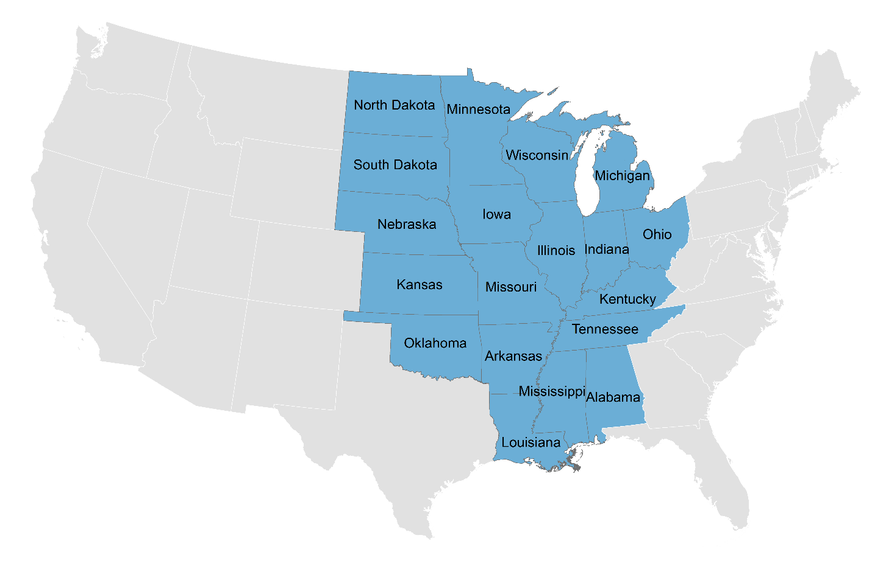
Building on those hints, then, the Walton analysis assembles an expansive Heartland built on states that begin with the classic Midwest; includes parts of the South; but excludes both the original 13 American colonies and the Intermountain West (and so excludes West Virginia, once a part of an original colony: Virginia). Along these lines, the Walton Heartland is a mashup of all or most of four different U.S. Census Bureau regions: East North Central (Ohio, Michigan, Indiana, Illinois and Wisconsin); West North Central (Missouri, Kansas, Iowa, Minnesota, Nebraska, South Dakota and North Dakota); East South Central (Kentucky, Tennessee, Alabama and Mississippi); and West South Central (from which Arkansas, Oklahoma and Louisiana are included).
As defined here, then, the Heartland consists of nearly 1.1 million square miles—roughly one-third of the national landmass—sprawling across 19 mostly inland states.
As such, the Heartland region constitutes a cross-cutting middle of the nation with an economy that is bigger than Germany’s and is just a bit smaller than Japan’s—the fourth largest economy in the world.

The State of the Heartland: Indicators
What goes into the factbook? “The State of the Heartland: Factbook 2018” consists of two components: a group of measures tracking prosperity “Outcomes” in the region followed by an additional set of measures tracking the region’s standing on core “Drivers” of such prosperity.
Along these lines, the “Outcomes” section first assesses the topline prosperity of the Heartland region in relation to the rest of the nation. Following that, a longer “Drivers” section evaluates the Heartland’s stock of the assets and conditions needed to ensure optimal outcomes. This section, at times, implies priorities for future self-improvement. Taken together, the two sets of indicators provide a first-of-its-kind resource for helping Heartland citizens and their leaders better understand the opportunities and challenges facing the region.
Further information about the particular nature and source data for each set of metrics can be found below and in the appendix labeled “Methods and Measures.”
Outcomes
The Outcomes section utilizes nine core indices to benchmark the region’s economic health relative to the rest of the nation. These indices address three dimensions of successful economic development: growth, prosperity, and inclusion. This categorization follows the economic development framework developed for the Brookings “Metro Monitor,” an annual benchmarking of large metropolitan areas’ economic performance.
What is economic development? Economic development is about putting the economy on a higher growth trajectory. As such, successful economic development boosts local fortunes by expanding the amount of growth present (growth); improving its quality through productivity gains and entrepreneurship that improve the standard of living (prosperity), and by doing that in ways that benefit all people (inclusion). To assess the Heartland’s economic standing and momentum, then, the following pages (and the parallel online interactive tool) display trend data within each of the three categories that track the Heartland’s progress in shaping an advanced, prosperous economy that works for everyone.
Measuring growth
The factbook’s growth indicators measure changes in the size of the Heartland economy both in aggregate and locally, especially in states. Growth is not everything in economic development or even the most important thing, but it matters and brings important benefits. Growth creates new opportunities for individuals and firms; growing regions benefit from an increased tax base. Along these lines, the factbook measures the Heartland’s growth on the basis of three straightforward measures of the size and growth of the Heartland’s labor market, economic output, and entrepreneurship:
- Jobs. Job numbers and their growth approximate the size of the economy and the level of labor demand by measuring the number of full- and part-time positions in a regional economy.

- Output. Real gross domestic product (GDP) measures the total value of the goods and services produced in a region, including wages and profits—a standard of economic output.

- Jobs at young firms. Changes in the total number of full- and part-time wage and salaried jobs at young, private-sector firms age five years or less measures the impact of entrepreneurship in a regional economy.
Measuring prosperity
Prosperity reflects changes in the wealth and income produced by an economy, which in turn shapes the potential living standards for workers and families. Prosperity grows in a place when increases in the productivity of its workers (whether through improved skills or the application of innovations) raises the value of workers’ labor—and so, in theory, their wages. As such, the factbook measures prosperity using three indicators designed to measure productivity, wages, and standard of living in the Heartland:
- Productivity. Output, as above, divided by the total number of local jobs, as above, yields the output per job, which is a basic measure of a place’s productivity.

- Average wage. Aggregate annual wages paid to workers divided by the total number of jobs yields the average annual wage per job in a location.

- Standard of living. Output, from above, divided by the total local population yields output per capita, which reflects place’s average standard of living.
Measuring inclusion
Inclusion indicators measure how the benefits of growth and prosperity in a region, state, town, or county are distributed among individuals. Inclusive growth enables more people to participate in the economy, increase and contribute their skills, and so raise aggregate demand while boosting prosperity and growth. In addition, ensuring that all people can contribute to and benefit from growth and prosperity helps to sustain social tranquility and widespread support for the policies on which growth and prosperity depend. In that sense, economic inclusion is the most effective way to ensure that economic growth is lasting. In this regard, the factbook measures labor market inclusion and inclusive financial well-being using three more indicators:
- Employment rate. The employment-to-population ratio measures the share of individuals age 18 to 64 who are currently employed.

- Median wage. The median wage measures the annual wage earned by a person in the middle of an area’s income distribution (among people at least 16 years old).

- Poverty rate. The poverty rate measures the share of local individuals who received income less than the federal poverty threshold.
Drivers
To achieve solid and rising outcomes, though, states and regions must concentrate on a set of key prosperity drivers. Strong positioning on these drivers will allow Heartland regions to maximize prosperity and respond to the economic forces, such as globalization, technological change, demographic transition, and declining national investment in economic growth and opportunity.
To assess the region’s standing, then, the second “Drivers” section of the factbook (along with the online interactive) discusses 17 additional measures focused on four crucial sources of prosperity: tradeable industries, human capital, innovation, and infrastructure. Measures arrayed across these categories undertake to evaluate the Heartland’s stock of the assets and conditions needed to ensure strong and improving outcomes on the preceding measures of inclusive growth. Here’s how the measures populate the four categories:

Tradeable industries
Tradeable, or export-oriented, industries support regional competitiveness by driving productivity higher and bringing new wealth into an economy from outside the region. Such industries create a multiplier effect throughout the region that spurs additional economic growth and improves the standard of living. The factbook looks at tradeable industries in the Heartland with four measures:
- Advanced industries. R&D- and STEM worker-intensive advanced industries—ranging from automotive manufacturing to renewable energy to digital services—anchor regional economies with their high-productivity, good-paying innovation and export activity.

- Exports. Exports generate financial inflows for states and communities and also expand firms’ customer bases, increase firms’ competitiveness, and support good-paying jobs.

- Agriculture. Beyond generating much of the nation’s food supply, agricultural output anchors a long agri-food chain that generates substantial U.S. employment as well as the nation’s world-leading food exports.
- Energy. Energy production is a significant source of prosperity, both as an export-oriented industry sector and as an input for nearly every other good and service in the economy.

Human capital
Local workers’ skills and talents are critical to enhancing productivity, raising incomes, and driving economic growth. Cultivating a skilled and educated workforce, and connecting those workers to employment, are therefore critical for regional success. The region’s human capital is measured using eight indicators:
- Population. Population growth bolsters labor supply and enhances consumer demand. It also serves as a signal of local success, as individuals move to areas with stronger economic opportunity.

- Young adult population. Adults aged 18-to-34 are the largest segment of the U.S. workforce and an important consumer market. As a result, they are a sought-after source of state in-migration.
- Bachelor’s degree attainment. A bachelor’s degree leads to higher wages, better health, and greater job security, and regions with higher college graduation rates see stronger productivity, output, and consumption.

- Racial bachelor’s degree gap. Racial bachelor achievement gaps measure the variance in bachelor’s degree across different ethnic groups, and can be a major drag on local and regional economies. Such gaps deprive the economy of talent and depress productivity.
- Adult obesity. Obesity, measured here using adult obesity rates, negatively impacts worker health and productivity, and has been estimated to significantly lower GDP. In addition, this burden falls disproportionately on low-income populations, exacerbating inequality.
- Opioid prescription rate. The opioid epidemic, here measured by opioid prescriptions per 100 people, is both a human tragedy and economic crisis, resulting in lost income for families, productivity losses for firms, diminished tax revenue, and increased health care and other social costs

Innovation
The innovation capacities of places are a key driver of long-term economic performance. Innovation allows economies to develop and deploy new commercial applications and start more new businesses. In addition, innovation can catalyze faster growth while also making a region more resilient in the face of disruptive change, in part by allowing local businesses to maintain industrial competitiveness. The factbook, therefore, measures innovation by assessing the assets required to both generate new technologies and translate them into new economic opportunities. Five indicators are employed:
- R&D spending. R&D spending, measured by the percent of gross domestic product spent on R&D, generates new products and processes that boost productivity and support economic growth.
- University technology transfer rankings. These rankings measure which universities are most effective at converting research into commercial and intellectual property, an important source of product and industry innovations.
- Venture capital spending. Venture capital, measured in the amount of VC spending per state, enhances entrepreneurship by helping to create new firms, as well as improving the operations of startup firms.
- Metropolitan area economic activity. Cities and their surrounding areas generate the majority of U.S. output and exports, and are hubs for highly productive workers, so measuring the output produced by metropolitan areas is an important benchmark.
Infrastructure
Infrastructure, both physical and digital, connects people and businesses to the broader economy. The way that land is used has a major impact on both the growth of a region and how inclusive it is for people of all means. The factbook measures infrastructure and the built environment using three indicators:
- Growth by community type. The distribution of growth across place—here reflected in population growth--is a critical determinant of growth, prosperity, and inclusion.

- Housing values. The Heartland’s relatively low housing values bolster households’ disposable income, boost consumer spending, and help attract in-migration, but can also make it more difficult for homeowners to build wealth.
- Broadband access. Broadband is essential to work, study, and remain connected in the 21st-century economy. Gaps in access to affordable, high-speed broadband hurt workers’ well-being as well as undercut regions’ productivity, output, and growth.

*
Overall, absolute and change-over-time readings on these measures of performance and capacity are utilized throughout the factbook. The indicators are then used to assess the relative standing of the Heartland compared to the rest of the country as well as the relative performance of states and sometimes communities within the Heartland.

The State of the Heartland: Factbook 2018

Outcomes

Sub section title page

Growth
Indices from the growth section of State of the Heartland factbook show a region getting its feet under it after a period of struggle.
While the 19-state Heartland suffered a lost decade of net negative job growth after the turn of the millennium, the region has stabilized since the end of the Great Recession. Since 2010 all 19 states have added jobs, while 18 have seen output increases. In fact, North Dakota, Tennessee, and Michigan have all emerged as national growth stars, ranking in the top 20 of the 50 states for employment growth, during the current decade.
With that said, neither Heartland employment nor output growth has in the aggregate kept pace with that in the rest of the nation. And on a measure of economic “dynamism”—employment in young firms—the region significantly underperforms the rest of the country. Only six of the region’s 19 states have shown positive growth in such employment since 2010, and as a whole, the region lagged even the torpid pace of new-firm employment growth in the rest of the country. An isolated bright spot here was North Dakota, which led the nation with its strong growth rate for employment at new firms.

Jobs
Job growth creates new opportunities for individuals, firms, and governments.
Since the start of the most recent economic recovery, job growth in the Heartland has been consistently positive, growing at a compound annual growth rate (CAGR) of 1.3 percent. (Annual growth is measured using CAGRs throughout the report). Nonetheless, this still lags the rest of the nation’s 1.9 percent annual growth rate. The Heartland’s job growth rate slowed in the most recent available year, however, falling to 0.8 percent between 2016 and 2017, versus 1.7 percent in the rest of the country.
Every Heartland state has shown net annual job growth since 2010, with several standout performers. North Dakota led the way with 2.1 percent annual job growth since 2010. Tennessee and Michigan have also posted strong job growth during that time, with annual increases of 2 percent and 1.9 percent, respectively. Likewise, Tennessee has led the Heartland in job growth from 2016 to 2017, with the growth of 1.5 percent, followed by Minnesota and Michigan at 1.4 percent and 1.3 percent, respectively.
While job growth has been healthy in recent years, on a longer timeline, the Heartland has struggled compared to the rest of the country. From 2001 to 2017 the Heartland added fewer than 1.3 million jobs, for an annual growth rate of 0.2 percent, compared to nearly the 11 million jobs added in the rest of the country, a 0.8 percent annual growth rate.
Overall, most individual Heartland states have seen slow job growth since 2001. North Dakota was the exception to this trend, leading the nation with annual job growth of 2 percent since 2001, largely driven by the state’s oil and gas boom. Conversely, Michigan, and to a lesser extent Ohio, have seen overall negative job growth since 2001, with annual job losses of 0.3 percent and 0.1 percent, respectively. Those numbers reflect the loss in manufacturing jobs in those states, driven by increased automation and international competition, and exacerbated by the particularly severe impacts of the Great Recession.
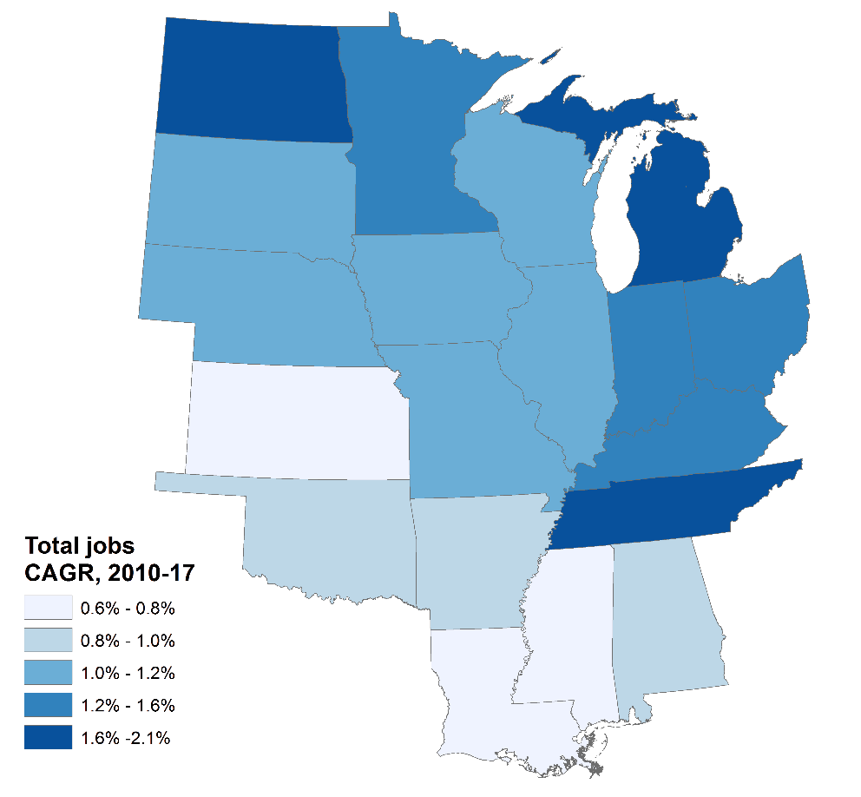
Source: Brookings analysis of QCEW data
Name | Total jobs,  2017 | CAGR,  2010-17
North Dakota | 414,000 | 2.1%
Tennessee | 2,931,000 | 2.0%
Michigan | 4,296,000 | 1.9%
Minnesota | 2,856,000 | 1.6%
Indiana | 3,018,000 | 1.6%
Kentucky | 1,874,000 | 1.3%
Ohio | 5,365,000 | 1.3%
South Dakota | 423,000 | 1.2%
Nebraska | 973,000 | 1.2%
Wisconsin | 2,850,000 | 1.1%
Missouri | 2,782,000 | 1.1%
Illinois | 5,932,000 | 1.1%
Iowa | 1,540,000 | 1.0%
Alabama | 1,937,000 | 0.9%
Oklahoma | 1,581,000 | 0.9%
Arkansas | 1,201,000 | 0.8%
Kansas | 1,371,000 | 0.8%
Mississippi | 1,128,000 | 0.7%
Louisiana | 1,907,000 | 0.6%
Heartland | 44,378,000 | 1.3%
Non-Heartland | 99,483,000 | 1.9%
Source: Brookings analysis of QCEW data

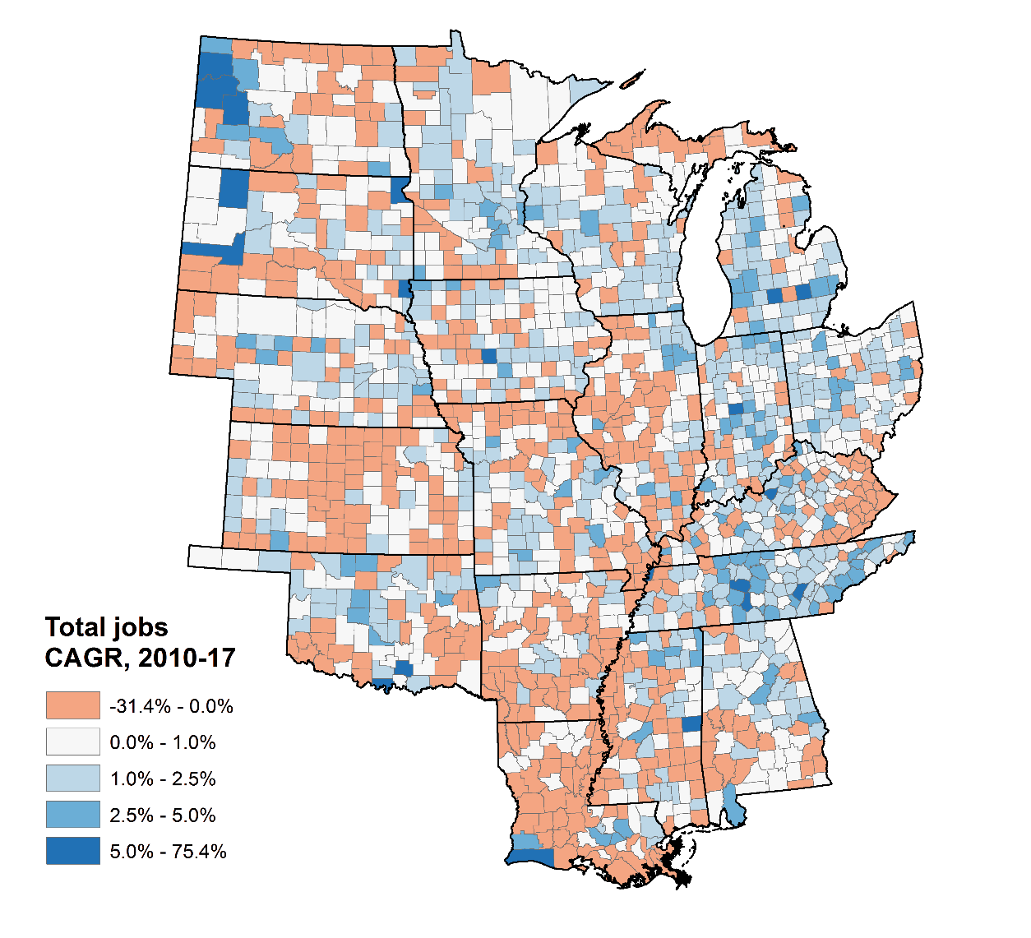
Source: Brookings analysis of QCEW data

Output
The Heartland produced some $4.9 trillion in goods and services in 2016, placing the region on par with Japan as an economic power. This compares to a gross domestic product (GDP) of $12.8 trillion in the rest of the United States, which means the Heartland generated 27.7 percent of the nation’s output in 2016.
In terms of change over time, however, the Heartland’s output growth has been tepid since 2010, with real GDP growth amounting to just 1.4 percent per year, compared to 1.9 percent in the rest of the country. As a result, the Heartland’s share of national GDP has fallen slightly since 2010.
Turning to the geography of output, the more densely-populated eastern Heartland is home to the largest state-level economies in the region. Illinois tops the list, with a gross state product (GSP) of $746 billion, followed by Ohio at $586 billion and Michigan at $472 billion. These Heartland economies rank fifth, seventh, and twelfth among U.S. states, respectively.
As to output growth, North Dakota has seen the fastest economic growth in the Heartland, and the nation as a whole, with the real annual growth of 5 percent since 2010, largely due to the rapid growth of the state’s energy sector driven by the spread of hydraulic fracturing. Tennessee has seen the second-fastest growth in the Heartland, with real growth of 2.4 percent annually. That output growth placed the state sixth among all states.

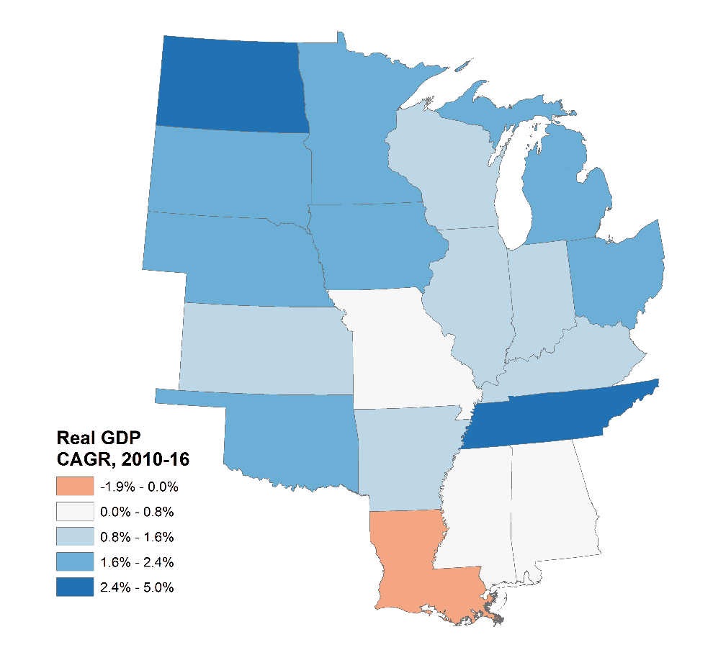
Source: Brookings analysis of Emsi data
Name | Real GDP,  ($mil) 2016 | CAGR,  2010-16
North Dakota | $52,714 | 5.0%
Tennessee | $321,258 | 2.4%
Iowa | $171,812 | 2.1%
South Dakota | $47,043 | 2.0%
Nebraska | $108,885 | 2.0%
Oklahoma | $185,149 | 2.0%
Michigan | $472,497 | 2.0%
Minnesota | $325,438 | 1.8%
Ohio | $586,487 | 1.7%
Wisconsin | $293,749 | 1.5%
Indiana | $320,016 | 1.3%
Illinois | $746,499 | 1.2%
Kentucky | $190,585 | 1.1%
Kansas | $148,006 | 1.1%
Arkansas | $116,865 | 1.0%
Alabama | $197,544 | 0.8%
Missouri | $287,030 | 0.8%
Mississippi | $105,219 | 0.4%
Louisiana | $227,721 | -1.0%
Heartland | $4,904,518 | 1.4%
Non-Heartland | $12,801,808 | 1.9%
Source: Brookings analysis of Emsi data

Jobs at young firms
Jobs at private-sector firms less than five years old are a key measure of economic vitality as reflected by entrepreneurship.
By that measure, entrepreneurship is a weak spot for the region. Both job share at young firms and employment growth at young firms in the Heartland trail the rest of the country.
In 2016 there were slightly fewer than 3.3 million Heartland workers at young firms, which accounted for 9 percent of all Heartland jobs. Non-Heartland states, meanwhile, had nearly three times as many (9.3 million) workers at young firms, accounting for 11.6 percent of all jobs. Since 2010, the share of jobs at young firms has declined in both Heartland and non-Heartland states, falling by 1.2 percentage points in the Heartland and 1.4 percentage points elsewhere. However, in terms of absolute numbers, jobs at young firms increased by over 220,000 in non-Heartland states but declined by nearly 65,000 in the Heartland.
The geography of jobs at young firms varies. While the largest absolute numbers of young-firm workers are situated in the more urbanized eastern Heartland, the fastest growth is occurring in western Heartland states. Illinois leads the Heartland, and ranks fifth nationally, for its absolute number of jobs at young firms with 443,000. Ohio ranks second in the Heartland and eighth in the U.S. with 372,000, and Michigan is third in the Heartland and 10th in the country with 334,000. However, since 2010 those states have seen flat-to-negative growth in employment in young firms. North Dakota, by contrast, saw the fastest growth in employment at small firms between 2010 and 2016, with an annual increase of 4.2 percent. It also saw the largest increase in the share of jobs at young firms, and now leads the Heartland with 11.6 percent of its jobs at young firms, up 0.4 percentage points since 2010. Nebraska was the only other Heartland state to see both absolute growth in employment at young firms and an increase in job share at young firms, with annual growth of 2.2 percent between 2010 and 2016, second fastest in the Heartland, and an increase in job share of 0.4 percentage points, to 9.8 percent.

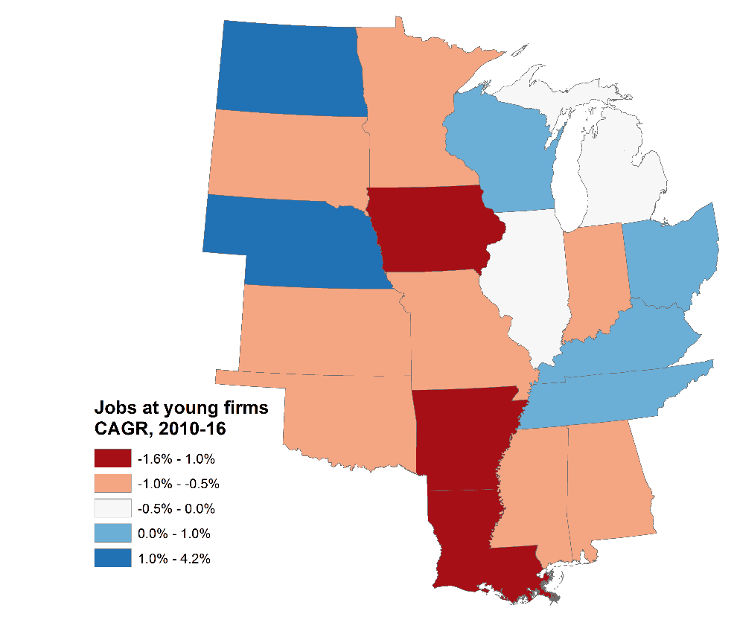
Source: Brookings analysis of LEHD-QWI data
Name | Jobs at young firms, 2016 | Share of all jobs, 2016 | Share change,  2010-16
North Dakota | 39,000 | 11.6% | 0.4%
Nebraska | 77,000 | 9.8% | 0.4%
Wisconsin | 201,000 | 8.4% | -0.7%
Ohio | 372,000 | 8.3% | -0.8%
Kentucky | 133,000 | 8.7% | -0.9%
Illinois | 443,000 | 8.9% | -1.0%
Alabama | 149,000 | 9.8% | -1.1%
Kansas | 99,000 | 8.9% | -1.1%
Missouri | 204,000 | 9.0% | -1.2%
Tennessee | 219,000 | 9.0% | -1.3%
Minnesota | 199,000 | 8.4% | -1.4%
Mississippi | 87,000 | 9.9% | -1.4%
Indiana | 200,000 | 7.9% | -1.5%
Iowa | 98,000 | 7.8% | -1.5%
South Dakota | 34,000 | 10.3% | -1.6%
Oklahoma | 140,000 | 11.3% | -1.7%
Arkansas | 98,000 | 10.2% | -1.7%
Michigan | 334,000 | 9.4% | -1.8%
Louisiana | 173,000 | 10.8% | -2.3%
Heartland | 3,297,000 | 9.0% | -1.2%
Non-Heartland | 9,341,000 | 11.6% | -1.4%
Source: Brookings analysis of LEHD-QWI data

Section title page

Prosperity
Prosperity indicators from the factbook show that the Heartland has slightly boosted its standard of living in this decade.
All 19 Heartland states enjoyed increased standards of living; all 19 posted increases in the average wage; and 12 of the 19 states saw productivity increases.
Importantly, on all three of the factbook’s prosperity measures, the Heartland has slightly narrowed the gap between its standard of living and that of the rest of the country. Likewise, the average wage in the Heartland has increased by 1 percent a year since 2010, while the measure ticked down nearly that much elsewhere in the rest of the country.
The upshot: The region has slightly improved its standing on several crucial measures of well-being.
The remaining problem: The Heartland’s improving aggregate standard of living still remains nearly 15 percent lower than that of the rest of the country.

Productivity
To the extent a region or a state is productive, it is more likely to prosper.
For that reason, it is welcome that productivity in the region grew at 0.08 percent a year from 2010 to 2016, surpassing the non-Heartland average of -0.05 percent. Progress on this crucial measure will be essential in the coming years.
And yet, neither that rate of growth nor the region’s absolute level of real output per worker of $111,000—which lags the $131,000 level of the rest of the country—appear adequate. In fact, not a single Heartland state boasts higher productivity than the non-Heartland average. Even Heartland-leading Illinois lags that benchmark at $127,000 per worker.
Nevertheless, the region’s recent progress has helped to shrink its deficit. In this regard, the five states with the nation’s fastest productivity growth from 2010 to 2016 were all in the Heartland and include: North Dakota (2.4 percent), Oklahoma (1.0 percent), Iowa (0.9 percent), South Dakota (0.7 percent), and Nebraska (0.7 percent). At the same time, though, six states in the region—Alabama, Kentucky, Indiana, Mississippi, Missouri, and Louisiana—actually saw an outright decline in productivity over the same period, with Louisiana experiencing an annual rate of contraction of -1.7 percent. By 2016, real output per worker in the state had fallen by $13,000.
One final note: Energy industries—which can distort productivity measures given their high value-added and cyclical nature—did not play a large role in the region’s middling showing on productivity. The post-crisis boom in this set of industries had largely ended by 2015, such that their net impact on energy-producing states in the Heartland was minimal and for the most part slightly negative. North Dakota was the one exception where the fracking revolution juiced productivity growth, with energy both directly growing productivity at a rate of 0.2 percent annually, as well as having spillover effects into other industries.

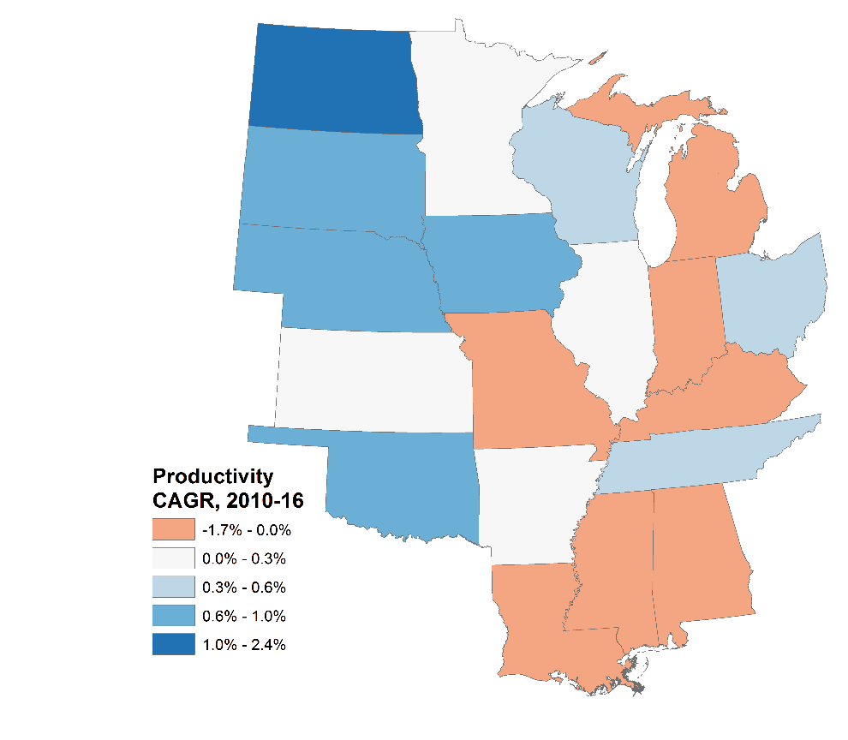
Source: Brookings analysis of Emsi and QCEW data
Name | Productivity, 2016 | CAGR,  2010-16
North Dakota | $126,000 | 2.4%
Oklahoma | $117,000 | 1.0%
Iowa | $112,000 | 0.9%
South Dakota | $112,000 | 0.7%
Nebraska | $112,000 | 0.7%
Tennessee | $111,000 | 0.4%
Ohio | $110,000 | 0.3%
Wisconsin | $104,000 | 0.3%
Minnesota | $116,000 | 0.2%
Kansas | $108,000 | 0.2%
Arkansas | $98,000 | 0.2%
Illinois | $127,000 | 0.0%
Michigan | $111,000 | 0.0%
Alabama | $103,000 | -0.1%
Kentucky | $102,000 | -0.2%
Indiana | $107,000 | -0.3%
Mississippi | $94,000 | -0.3%
Missouri | $104,000 | -0.4%
Louisiana | $119,000 | -1.7%
Heartland | $111,000 | 0.1%
Non-Heartland | $131,000 | 0.0%
Source: Brookings analysis of BEA and QCEW data
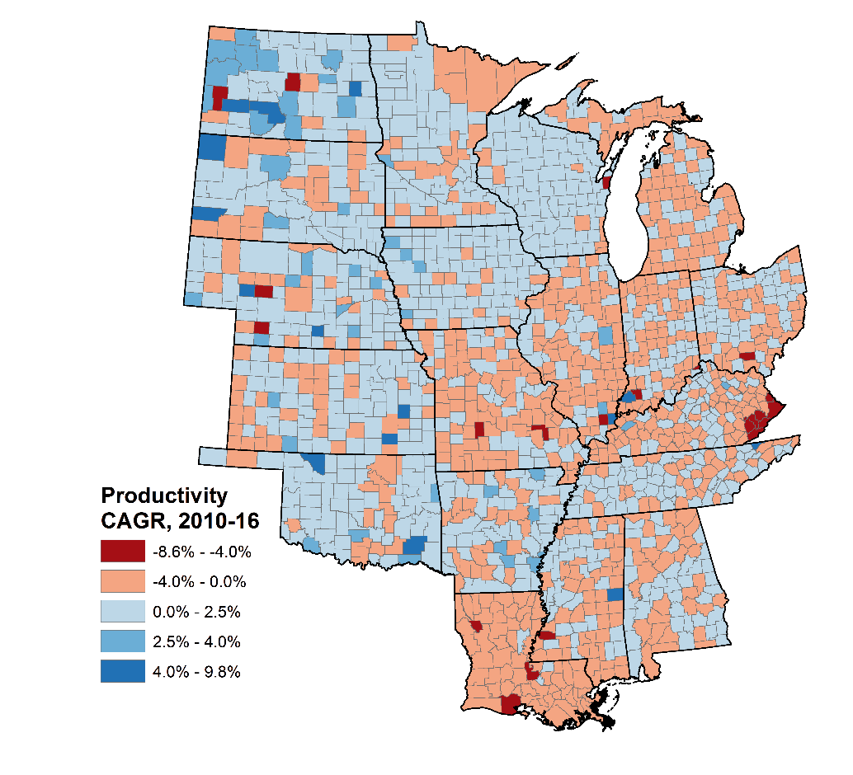
Source: Brookings analysis of Emsi and QCEW data

Average wage
High and rising wages indicate strong labor demand, and, in turn, can support further expansion as workers’ greater purchasing power flows into consumption. What’s more, higher pay—far from just a cost to employers—travels with and tends to support productivity gains.
Although the Heartland’s average purchasing power-adjusted annual wage slightly trails the rest of the nation, its growth since 2010 has exceeded the rest of the nation, which has led to some convergence. Nonetheless, wage growth in the U.S., both in the Heartland and elsewhere, has been tepid during that time. In 2016, the average Heartland worker made $48,000 per year when adjusted for purchasing power, compared to an average wage of $49,000 in the rest of the country. Since 2010, however, the average purchasing power-adjusted wage in the Heartland has grown by an even 1 percent per year, compared to 0.8 percent in the rest of the country.
Significant geographical variations characterize both wage levels and growth rate. Only Illinois, with an average purchasing power-adjusted wage of $52,000, and Minnesota, with an average purchasing power-adjusted wage of $49,000, exceed the national non-Heartland average wage in 2016. In terms of wage growth, however, the Heartland fares better. The region was led by North Dakota, which led the nation with its annual growth of 2.3 percent since 2010. South Dakota followed, posting the second fastest annual growth in the U.S. at 1.4 percent per year. On the other end of the spectrum, Mississippi has seen the slowest average annual wage growth in the Heartland, and third-slowest in the country, at 0.3 percent per year. Also lagging were Louisiana and Missouri, which have both seen only 0.4 annual wage growth since 2010.

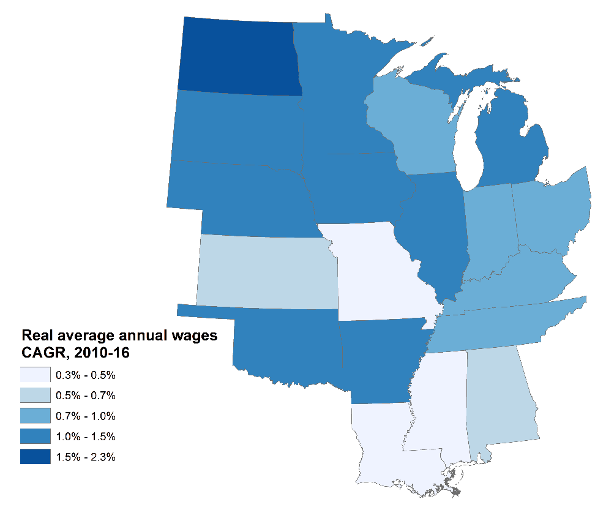
Source: Brookings analysis of BEA data
Name | Average wage, 2016 | CAGR,  2010-16
North Dakota | $47,000 | 2.3%
South Dakota | $42,000 | 1.4%
Michigan | $49,000 | 1.2%
Illinois | $52,000 | 1.2%
Iowa | $44,000 | 1.1%
Nebraska | $45,000 | 1.1%
Minnesota | $49,000 | 1.1%
Oklahoma | $45,000 | 1.1%
Arkansas | $44,000 | 1.0%
Indiana | $45,000 | 1.0%
Wisconsin | $45,000 | 1.0%
Ohio | $49,000 | 0.9%
Kentucky | $45,000 | 0.9%
Tennessee | $47,000 | 0.8%
Alabama | $46,000 | 0.6%
Kansas | $45,000 | 0.6%
Missouri | $48,000 | 0.4%
Louisiana | $47,000 | 0.4%
Mississippi | $41,000 | 0.3%
Heartland | $48,000 | 1.0%
Non-Heartland | $49,000 | 0.8%
Source: Brookings analysis of BEA data

Standard of living
GDP per capita, or GDP divided by population, signals the average standard of living for an economy. And on that measure, the Heartland lags the rest of the nation in terms of its absolute level. In 2016, after all, the Heartland’s GDP per capita reached $50,000, at a time the rest of the country came in at $57,000.
And yet, since 2010 the Heartland has been catching up somewhat with the rest of the nation. Since the recession, GDP growth per capita in the Heartland has been increasing by 1.1 percent per year—a growth rate that outpaced the rest of the country’s 0.9 percent annual increases.
North Dakota has both the highest per capita GDP in the Heartland, at $70,000, and has seen the fastest growth in the region since 2010, at 3 percent annually. No other state has sustained even 2 percent growth during that time, and North Dakota’s growth significantly exceeded the fastest growing non-Heartland states, which have been led by California’s 1.7 percent growth. However, much of the state’s rapid increase in GDP has been driven by energy extraction, which has had wild swings in recent years. So while North Dakota still maintains the highest Heartland standard of living, it has fallen from a high of $80,000 in 2014, an annual decline of 6.4 percent.
Other than North Dakota, just three Heartland states had a per capita GDP greater than the non-Heartland average in 2016: Minnesota, Illinois, and Nebraska. With that said, 12 Heartland states have seen their per capita GDP grow faster than the non-Heartland average since 2010. Michigan trailed only North Dakota in per capita GDP growth nationwide, with an annual growth rate of 1.9 percent. In fact, Michigan has shown the strongest growth in the Heartland in recent years, with annual growth of 2.7 percent from 2014-2016, lagging only Massachusetts’ 3.1 percent growth nationwide. Since 2010, Tennessee, Iowa, and Ohio have all also had growth rates of 1.6 percent or higher, putting them among national leaders as well.
Long to short: The Heartland is making progress in raising both its absolute and relative standard of living—a crucial achievement.
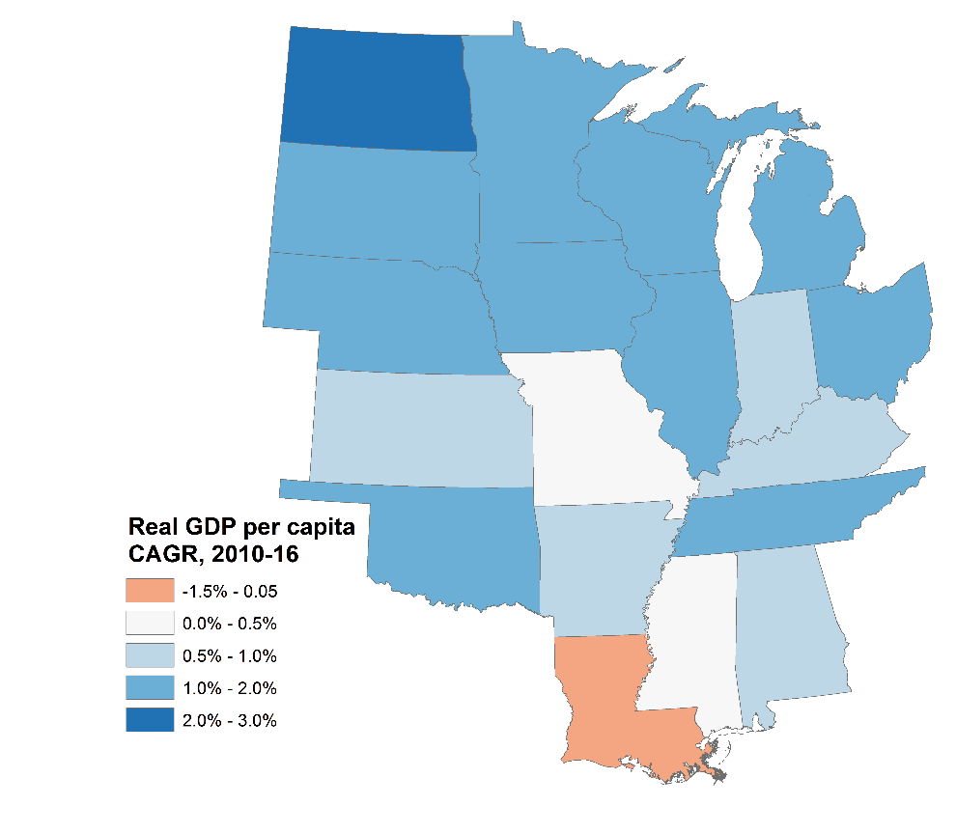
Source: Brookings analysis of Census-PEP and Emsi data
Name | Real GDP per capita, 2016 | CAGR,  2010-16
North Dakota | $70,000 | 3.0%
Michigan | $48,000 | 1.9%
Tennessee | $48,000 | 1.7%
Iowa | $55,000 | 1.6%
Ohio | $50,000 | 1.6%
Nebraska | $57,000 | 1.3%
Wisconsin | $51,000 | 1.3%
Oklahoma | $47,000 | 1.3%
Illinois | $58,000 | 1.2%
Minnesota | $59,000 | 1.2%
South Dakota | $55,000 | 1.1%
Indiana | $48,000 | 1.0%
Kansas | $51,000 | 0.8%
Kentucky | $43,000 | 0.8%
Arkansas | $39,000 | 0.6%
Alabama | $41,000 | 0.5%
Missouri | $47,000 | 0.5%
Mississippi | $35,000 | 0.4%
Louisiana | $49,000 | -1.5%
Heartland | $50,000 | 1.1%
Non-Heartland | $57,000 | 0.9%
Source: Brookings analysis of Census-PEP and Emsi data

Section title page

Inclusion
Overall, the Heartland is improving its standing on basic measures of economic inclusion. Eighteen of the 19 Heartland states saw their employment-to-population ratios rise from 2010 to 2016; all 19 have welcomed median wage increases during that period, and 18 of the 19 states have experienced declines in the poverty rate since the recession.
At the most basic level Heartland workers have had greater success in finding jobs in recent years, to the point that the employment-to-population ratio now slightly exceeds not only that in the rest of the country, but also pre-financial crisis levels.
Equally encouraging is the fact that the region’s aggregate median wage grew at a time it was going sideways outside the region, and in fact goes farther than it does in the rest of the country.
With that said, while all Heartland states except Louisiana have seen their poverty rates decline since 2010, all states except North Dakota have higher poverty rates now than they did in 2001. There is more work to be done to make sure the Heartland truly inclusive.

Employment rate
Even more than the more common “unemployment rate,” the employment-to-population ratio—specifically, the share of individuals ages 20 to 64 currently employed—stands out as an effective measure of workers’ overall level of participation in the economy. Which makes the Heartland’s solid aggregate employment-to-population ratio a positive sign. In 2016, 72.8 percent of 20 to 64-year-olds were employed in the Heartland, compared to 72.4 percent in the rest of the nation. Employment-to-population ratio change was largely on par, improving by 3.2 percentage points in the Heartland from 2010 to 2016, and 3.4 percentage points elsewhere. In aggregate, then, the Heartland enjoys solid employment rates.
With that said, regional numbers obscure divergent labor market performance across Heartland states. Notably, the western Heartland leads the nation in employment-to-population ratio (staging a geographical dynamic that will be repeated in the factbook). Minnesota, North Dakota, Nebraska, Iowa, and South Dakota have the five highest employment-to-population ratios in the country, and Wisconsin is close behind at seventh overall. Each of these states has an employment-to-population ratio of at least 78.3 percent, led by Minnesota’s 81.1 percent, which far outpaces the non-Heartland average. Unfortunately, this strong performance is offset by weak labor markets elsewhere in the Heartland. Seven Heartland states, Mississippi, Alabama, Louisiana, Kentucky, Arkansas, Oklahoma, and Tennessee, struggle with employment-to-population ratios in the bottom 10 nationwide. Mississippi’s 65.2 percent ratio trails only West Virginia for the lowest in the United States.
State-level growth rates also show significant variance. While Michigan led the country with a 6 percentage point increase in its employment-to-population ratio between 2010 and 2016, North Dakota saw its employment-to-population ratio slip just slightly, though this was largely a function of the state having an already-high ratio.
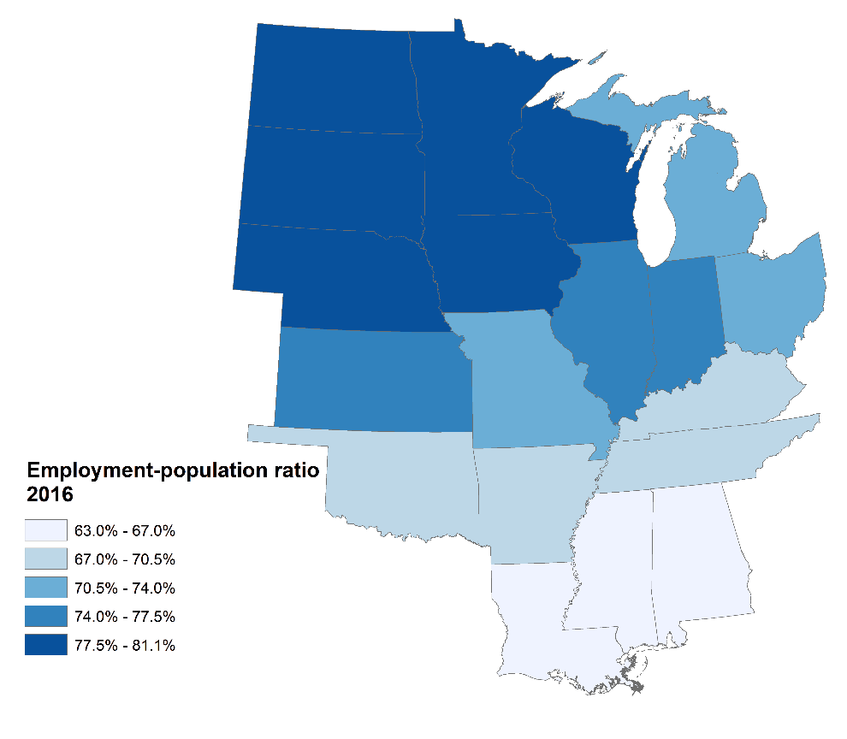
Source: Brookings analysis of 2010 & 2016 ACS 1-year estimates
State | Employment-population ratio, 2016 | Change,  2010-16
Michigan | 71.2% | 6.0%
Indiana | 74.1% | 4.7%
Kentucky | 67.7% | 4.0%
Ohio | 73.3% | 3.8%
Illinois | 74.4% | 3.6%
Minnesota | 81.1% | 3.6%
Tennessee | 69.6% | 3.5%
Wisconsin | 78.3% | 2.9%
Missouri | 73.2% | 2.8%
Mississippi | 65.2% | 2.6%
Alabama | 66.4% | 2.2%
Kansas | 76.2% | 1.6%
Nebraska | 80.4% | 1.5%
Arkansas | 68.3% | 1.2%
Iowa | 79.5% | 1.1%
Oklahoma | 69.4% | 0.9%
South Dakota | 79.0% | 0.8%
Louisiana | 66.6% | 0.2%
North Dakota | 80.9% | -0.1%
Heartland | 72.8% | 3.2%
Non-Heartland | 72.4% | 3.4%
Source: Brookings analysis of 2010 & 2016 ACS 1-year estimates

Median wage
Adjusting median wages for their local purchasing power yields a solid measure of the relative effective wage for a region’s middle class—an important measure of economic health and inclusion.
It is good news then, that when adjusted for purchasing power, the Heartland’s median annual wage surpasses the rest of the nation. Furthermore, its growth since 2010 significantly exceeds that elsewhere. This finding, which runs counter to the trend in average purchasing power-adjusted wage, indicates that relatively fewer gains flow to the top of the income distribution in Heartland states compared to the rest of the country.
In 2016, the median Heartland wage, adjusted for purchasing power, was $30,000 compared to just $28,000 elsewhere in the U.S. Furthermore, the gap has been growing since 2010—a period during which real wages grew 0.6 percent in the Heartland compared to -0.4 percent outside the region. This disparity was driven largely by the larger increase in consumer prices outside of the Heartland, particularly in housing, which has eroded purchasing power in the non-Heartland.
This positive story extends to the individual state level as well. In 2016, when adjusted for purchasing power, every Heartland state’s median wage exceeded the non-Heartland average. Additionally, between 2010 and 2016 every Heartland state had a positive median wage growth rate. And numerous Heartland states excelled. North Dakota—the region’s fastest grower and the fastest grower among all states—has seen its real hourly wage rise 2.4 percent a year since 2010. In fact, Heartland states accounted for seven of the top 10 fastest growing states, and 11 out of the top 15. Other top performers with annual growth rates in excess of 1.4 percent include Kentucky, Oklahoma, South Dakota, Nebraska, and Michigan. And while Mississippi had the lowest median wage and slowest growth rate among Heartland states, when adjusted for purchasing power it still outperformed the non-Heartland average in both categories.

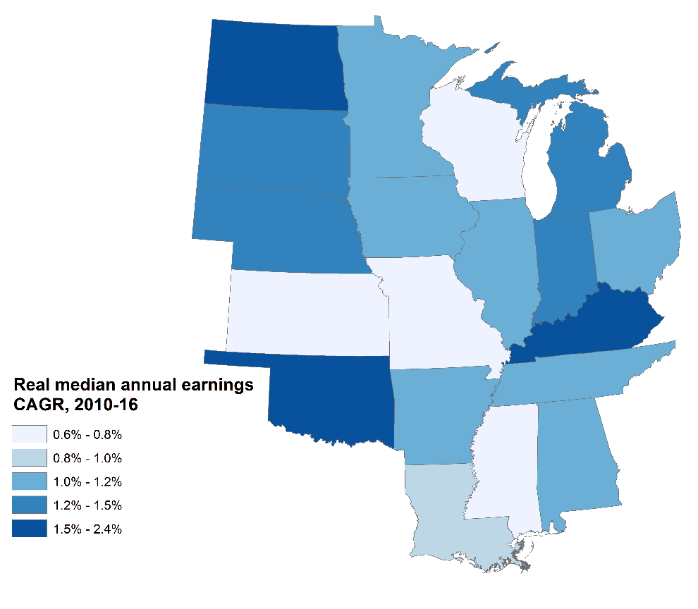
Source: Brookings analysis of 2010 & 2016 ACS 1-year microdata
Name | Median earnings,  2016 | CAGR,  2010-16
North Dakota | $35,000 | 2.4%
Kentucky | $31,000 | 1.7%
Oklahoma | $31,000 | 1.7%
South Dakota | $32,000 | 1.4%
Nebraska | $31,000 | 1.4%
Michigan | $29,000 | 1.4%
Indiana | $31,000 | 1.2%
Minnesota | $34,000 | 1.1%
Illinois | $32,000 | 1.1%
Arkansas | $29,000 | 1.1%
Tennessee | $30,000 | 1.1%
Iowa | $32,000 | 1.1%
Ohio | $32,000 | 1.1%
Alabama | $30,000 | 1.0%
Louisiana | $30,000 | 0.9%
Kansas | $31,000 | 0.8%
Missouri | $31,000 | 0.8%
Wisconsin | $31,000 | 0.7%
Mississippi | $29,000 | 0.6%
Heartland | $30,000 | 0.6%
Non-Heartland | $28,000 | -0.4%
Source: Brookings analysis of 2010 & 2016 ACS 1-year microdata

Poverty rate
Reducing poverty is a core goal of inclusive growth. Poverty restricts people’s ability to participate fully in the economy; alleviating it improves opportunities by improving health outcomes, improving schools, reducing crime rates, and strengthening job-seeking networks.
For the Heartland the scene is mixed. While in 2001 the Heartland had a lower rate of poverty than in the rest of the country, since then the Heartland’s poverty rate has risen by nearly twice as much as elsewhere. Since the start of the recovery in 2010, however, the poverty rate in the Heartland has fallen at nearly the same rate as the rest of the country, dropping by 1.2 percentage points compared to 1.3 percentage points for non-Heartland states. By 2016 the Heartland’s poverty rate was 14.6 percent of the population, compared to 13.8 percent elsewhere.
Poverty rates are the highest in the southern Heartland. Mississippi and Louisiana had the two highest poverty rates in the nation in 2016, at 21 percent and 20.1 percent, respectively. Kentucky had the third highest rate in the Heartland, and fifth highest in the United States, at 18.2 percent. On a sub-state level, the Heartland’s portion of the southern Black Belt region faces higher poverty than any individual state, with a poverty rate of 21.1 percent. The Heartland’s portion of Appalachia, likewise, struggles with a 17.7 percent poverty rate, which would be the seventh highest poverty rate in the country if it were a state.
The more sparsely populated, and whiter, states of the northern and western Heartland, meanwhile, tend to have lower poverty rates. Minnesota has the lowest poverty rate in the Heartland, and fourth lowest in the U.S., at 9.9 percent, followed by North Dakota at 10.5 percent, the 10th lowest in the U.S.
Changes in the poverty rate have varied across the Heartland. Unfortunately, Heartland states saw six of the seven largest increases in poverty between 2001 and 2016, with Michigan and Indiana registering the two largest poverty rate increases in the country, at 5.1 percentage points and 4.9 percentage points, respectively. On the other hand, North Dakota has seen the second largest reduction in its poverty rate in the country, and the largest in the Heartland, since 2001, with a decline of 0.8 percentage points. Luckily that tide has turned, and since 2010 every Heartland state except for one has seen a decrease in poverty, led by Tennessee’s 2 percentage point decrease, the eighth largest in the country. Nonetheless, Louisiana was one of only two states in the U.S. to see an increase in the poverty rate from 2010-2016, and its 1.2 percentage point increase was the largest in the U.S. during that time.

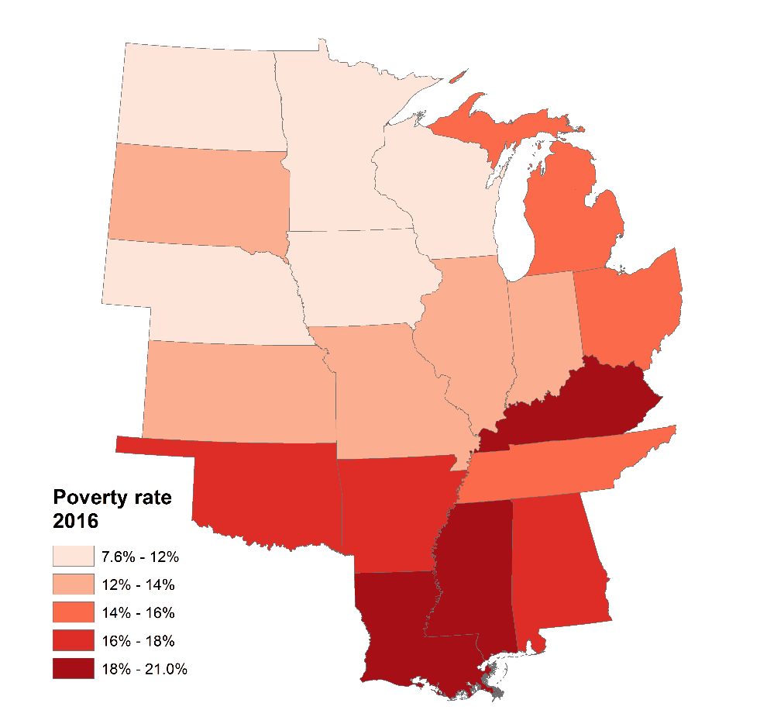
Source: Brookings analysis of SAIPE estimates
Name | Poverty rate,  2016 | Change,  2010-16
Tennessee | 15.8% | -2.0%
North Dakota | 10.5% | -1.9%
Michigan | 14.9% | -1.8%
Alabama | 17.2% | -1.7%
South Dakota | 12.9% | -1.7%
Minnesota | 9.9% | -1.6%
Arkansas | 17.2% | -1.5%
Wisconsin | 11.8% | -1.5%
Mississippi | 21.0% | -1.4%
Nebraska | 11.3% | -1.4%
Kansas | 12.2% | -1.3%
Missouri | 14.0% | -1.3%
Indiana | 14.0% | -1.3%
Ohio | 14.5% | -1.3%
Illinois | 13.0% | -0.8%
Iowa | 11.7% | -0.8%
Kentucky | 18.2% | -0.7%
Oklahoma | 16.1% | -0.7%
Louisiana | 20.1% | 1.2%
Heartland | 14.6% | -1.2%
Non-Heartland | 13.8% | -1.3%
Source: Brookings analysis of SAIPE estimates

Drivers

Tradeable industries
Measures from the factbook show that tradeable industries, the type of export-oriented industries that undergird regional competitiveness, are a bright spot for the Heartland. The region excels especially in high-tech advanced manufacturing, and several eastern Heartland states, including Indiana, Michigan, Kentucky, and Alabama, are national leaders on both advanced manufacturing output and employment.
Moving west, the region becomes more the nation’s bread basket and an important source of its energy output. All in all, the Heartland produces over half of the country’s agricultural output, with anchors of production in Iowa, Nebraska, and Minnesota. Some of this output is used to produce biofuels, which has helped turn Iowa into a major source of energy production. Other Heartland states, such as Oklahoma and Kansas, are pioneering U.S. wind energy, while North Dakota and Oklahoma are major players in the fracking revolution.
This economic activity produces strong exports that bring wealth into the region from outside. All but two Heartland states exceeded the non-Heartland average for exports as a share of gross state product in 2017.

Advanced industries
Advanced industries are the 50 manufacturing, energy, and services industries that conduct the most private-sector R&D and rely most heavily on STEM workers. While the Heartland notably lags the remainder of the nation on advanced—often digital—services employment, it is slightly more specialized in advanced industries activity as a whole than the rest of the country in terms output and employment, and it sees slightly faster growth of the overall sector.
Especially important here is the Heartland’s heavy focus on advanced manufacturing, which greatly exceeds that elsewhere.
This is a good thing, because the 37 advanced manufacturing industries—ranging from motor vehicles and aerospace to medical devices and pharmaceuticals—are the high-tech vanguard of U.S. manufacturing and export activity and support strong industrial innovation, long supply chains, and good-paying jobs for workers of varied skill levels.
Advanced manufacturing industries generated 9.8 percent of the Heartland’s economic output and 5.4 percent of its employment in 2016, compared to just 6.3 percent and 3.2 percent shares in the rest of the country. It is also important to note that Heartland advanced manufacturing industries have been growing faster than those in the rest of the country both since 2010 and since 2016.
Especially strong centers of advanced manufacturing activity include: Indiana, Michigan, Kentucky, and Alabama, each with more than 10 percent of output and 6 percent of employment driven by advanced manufacturing. In terms of growth, Kentucky has led the nation in both advanced manufacturing output and employment growth since 2010, with annual output growth of 6.9 percent and annual employment growth of 4.8 percent during that time. On the output side, Missouri, Michigan, and North Dakota rounded out the top four nationally, each with annual advanced manufacturing output growth above 5 percent, while Tennessee and Michigan trailed only Kentucky for fastest advanced manufacturing employment growth, with annual growth rates of 4.7 percent and 4.6 percent, respectively.

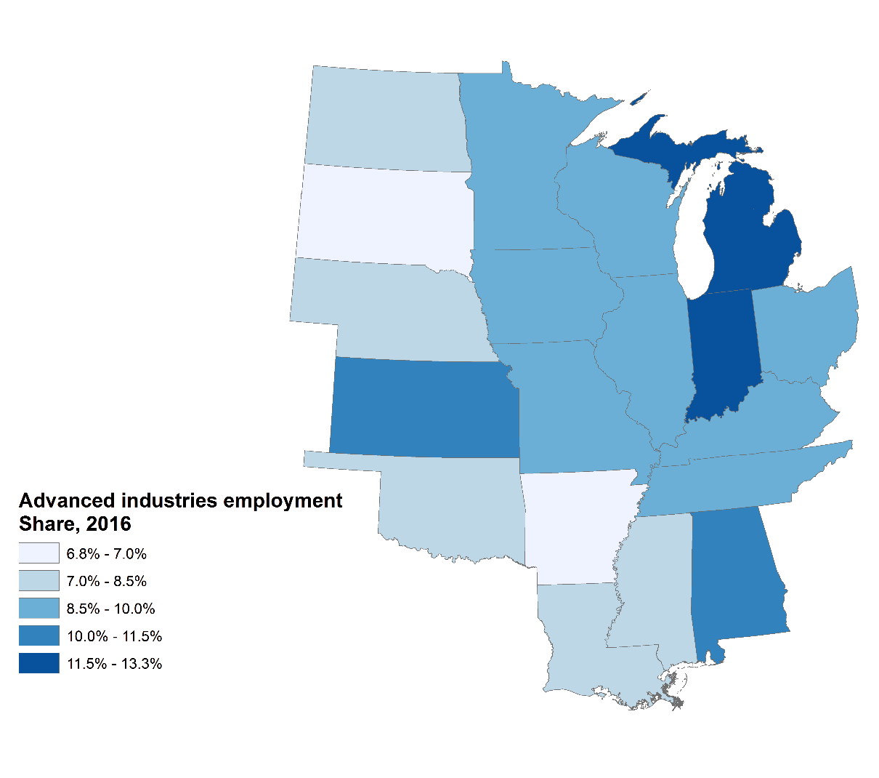
Source: Brookings analysis of Emsi data
 | Output, ($mil) 2016 | Employment, 2016 | Output CAGR, 2010-16 | Employment CAGR, 2010-16
Advanced manufacturing
Heartland | $479,654 | 2,376,000 | 2.5% | 2.2%
Non-Heartland | $810,346 | 3,152,000 | 0.6% | 0.5%
Advanced energy
Heartland | $115,063 | 192,000 | -2.8% | -0.2%
Non-Heartland | $274,651 | 414,000 | -2.4% | 0.8%
Advanced services
Heartland | $260,555 | 1,742,000 | 1.8% | 2.9%
Non-Heartland | $1,113,859 | 5,715,000 | 3.3% | 3.1%
Advanced industries
Heartland | $855,272 | 4,309,000 | 1.5% | 2.3%
Non-Heartland | $2,198,856 | 9,281,000 | 1.5% | 2.1%
Source: Brookings analysis of Emsi data

Exports
Exports drive prosperity, and the Heartland generates a higher share of its GDP from exports than does the rest of the nation.
In 2017, for example, the average export share of gross state product in the Heartland was 12.3 percent, compared to 9.6 percent elsewhere in the United States—a differential that reflects the strong connections Heartland states have with international markets, whether through manufacturing, agriculture, or energy. Overall, in fact, Heartland states exported $658 billion in goods and services in 2017, a 13-percent increase since 2010. This compares with non-Heartland exports of $1.3 trillion in 2017 and an increase of 17 percent since 2010.
At the same time, Heartland states vary significantly in terms of both their absolute levels of export output and the shares of their gross state product tied to exporting.
Illinois produced the most exports in absolute terms, at $80 billion, followed by Ohio at $79 billion, Michigan at $75 billion, and Indiana at $64 billion, demonstrating the impact of advanced manufacturing exports in the eastern Heartland.
In terms of export concentrations, Heartland states significantly outperform the rest of the country. Overall, all but two Heartland states exceeded the non-Heartland average for export concentration. Louisiana led the way, with exports accounting for 19.2 percent of gross state product, driven largely by exports of energy and agricultural products. It was followed by Indiana at 17.8 percent, with its focus on medical and automotive products, Michigan at 14.5 percent, primarily in automotive, and Iowa at 14.4 percent, mostly agricultural and agribusiness products. Such specializations in manufacturing and agriculture are a plus, but it bears noting that with them come particular exposure to the ramifications of trade policy changes both at home and abroad.

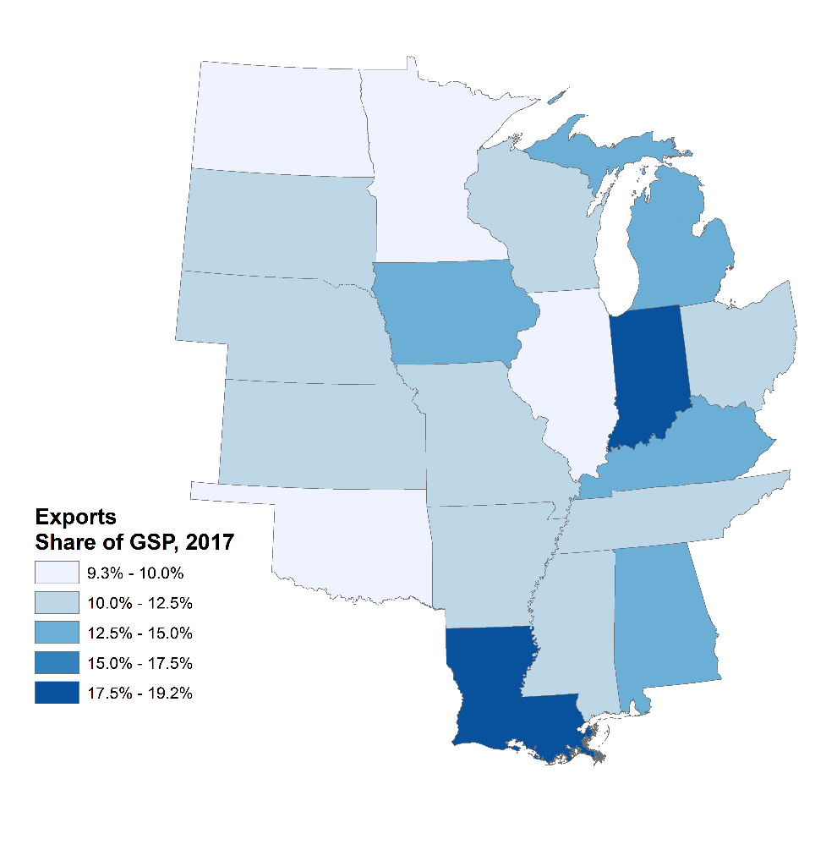
Source: Brookings, “Export Monitor 2018,” April 2018

Agriculture
Agriculture is also an important source of output and employment and with them prosperity. While farming itself accounts for around 1 percent of GDP and less than 2 percent of U.S. employment, it forms the basis of a $1 trillion agri-food chain that accounts for some 11 percent of U.S. employment, including as much as 20 percent of rural employment.
The U.S. Heartland anchors this economic engine. In 2016, Heartland states generated nearly 55 percent of the nation’s agricultural output, a full percentage point increase since 2010. From 2010 to 2016, the Heartland’s agrarian output grew by 1.2 percent per year, over twice as fast as non-Heartland states’ 0.5 percent annual growth.
Looking within the Heartland bread basket, states in the northern Heartland are significantly more agriculturally-oriented, which is reflected in both agricultural output and growth. Iowa leads the Heartland with $29 billion in agricultural output, accounting for 7.1 percent of the nation’s total agricultural output. Nebraska follows it with $23 billion in output (a national share of 5.7 percent), and Minnesota with $19 billion in output (a national share of 4.6 percent). All three are major corn and soy producers, with Nebraska and Minnesota also producing significant amounts of wheat. Meanwhile, Kentucky has seen the fastest growth in the Heartland ag sector since 2010, with an annual growth rate of 3.1 percent, followed by Nebraska and South Dakota, both at 2.7 percent. In all three states, soybean production accounted for the majority of growth in real cash receipts over the period. By contrast, five states, including Louisiana, Mississippi, Tennessee, Arkansas, and Alabama, saw negative growth between 2010 and 2016. Falling cash receipts in these states was overwhelming due to contractions in poultry raising and rice and cotton cultivation.
Escalating trade hostilities could impose additional downside risk for Heartland economies.

Energy
Energy development is another facet of the region’s solid presence in the tradeable economy.
In 2016, Heartland states accounted for 30 percent of the nation’s energy production, a slight decline since 2010. The Heartland’s overall energy production grew at an annual rate of 2.0 percent during that time, meanwhile, but that pace lagged the rest of the nation’s 2.6 percent annual growth.
With that said, key Heartland states have been hotspots of the decade’s energy boom, including renewables. On that front, the Heartland now produces 42 percent of U.S. renewable energy, primarily biofuels, biomass, and wind energy. Since 2010, renewables have seen a 3.5 percent annual growth rate in the Heartland, nearly on par with the rest of the nation’s 3.7 percent rate.
States with strong fossil fuel extraction led the Heartland in energy production and growth. Oklahoma led the way, contributing 5.0 percent of the nation’s overall energy supply, followed by North Dakota at 4.4 percent. North Dakota’s energy production growth of 19 percent per year between 2010 and 2016 was the fastest among Heartland states. Other rapidly growing states have included Ohio at 15 percent annual growth and Oklahoma at over 7 percent. All three states have become major centers of oil and gas production since the start of the “shale revolution” a decade ago. Coal producing states, on the other hand, have suffered, and energy production in Kentucky has shrunk by nearly 13 percent per year since 2010.
On the renewables front, Iowa leads the Heartland with a national share of almost 8 percent, buoyed by the production of corn-based biofuels. And several Heartland states have seen rapid growth in production of renewables, mostly wind energy, including Oklahoma at 17 percent annual growth, and Kansas at 12 percent.

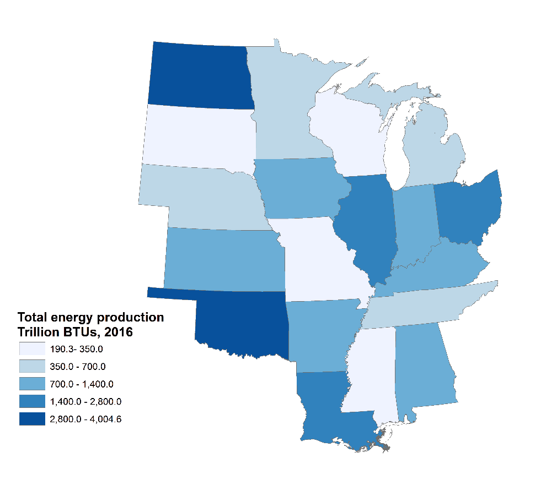
Source: Brookings analysis of EIA-SEDS data

Facing page

Human capital
The factbook’s indicators depict a region that is struggling to amass the human capital needed to propel broad-based prosperity.
One problem is visible in the factbook’s basic population measures which show that the Heartland continues to grow at a slower rate than the rest of the country. This slow-growth trend also applies to the region’s young adult population, including in-migration. Such trends portend further labor-market limitations.
Also problematic is the region’s low bachelor’s degree attainment and acute racial attainment gaps. These shortfalls are likely central factors in the large and persistent income gap between Heartland residents and those elsewhere. Such education and racial challenges also likely exacerbate the region’s crisis of male labor force involvement. Alongside these economic struggles is the growing opioid addiction crisis, which has heavily impacted several Heartland states, including Alabama, Arkansas, Kentucky, Ohio, and Tennessee.
“The State of the Heartland: Factbook 2018” points to the significant need to raise the region’s stock of human capital. Doing so would help the Heartland make significant gains in the coming years.

Population
Sustainable population growth, particularly of working-age individuals, strengthens a region’s labor supply, consumer demand, and tax revenue. Population growth can also be a sign of state or local success, as people want to move to areas offering more desirable economic opportunities and consumer options.
In 2017, 96.7 million people lived in the Heartland, accounting for 30.3 percent of the nation’s population. Since 2010, however, the Heartland’s population has increased by just less than 2.2 million, for an annual growth rate of 0.3 percent. Meanwhile, the rest of the country grew faster—by 14.2 million people during that time, an annual growth rate of 0.9 percent.
Heartland states vary widely in total population. Illinois ranks first in the Heartland and sixth nationwide in total population, with 12.8 million people. However, it has seen the slowest growth in the Heartland during that time, with a population decrease of 40,000 people, nearly 34,000 of which occurred between 2016 and 2017 alone. Ohio is the second largest state in the Heartland, with 11.7 million people, and has seen slight annual growth of 0.1 percent since 2010. North Dakota has seen the fastest population increase in the Heartland since 2010, and third fastest in the U.S., with an annual population growth of 1.6 percent. However, it did not see any population growth between 2016 and 2017, likely linked to the state’s slowdown in oil production. South Dakota ranks second in the Heartland, with annual growth of 0.9 percent. Both states are relatively small, with fewer than one million people, but are buoyed by strong job growth in the past decade stemming from opportunities in booming oil and gas industries.

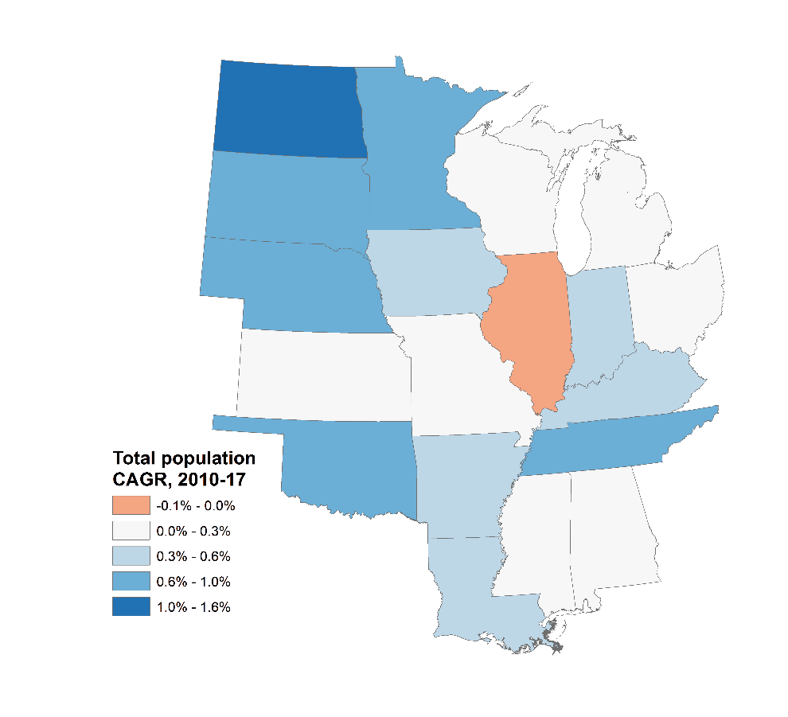
Source: Brookings analysis of Census-PEP data
Name | Total population, 2017 | CAGR,  10-17
North Dakota | 755,000 | 1.6%
South Dakota | 870,000 | 0.9%
Tennessee | 6,716,000 | 0.8%
Minnesota | 5,577,000 | 0.7%
Nebraska | 1,920,000 | 0.7%
Oklahoma | 3,931,000 | 0.6%
Iowa | 3,146,000 | 0.4%
Louisiana | 4,684,000 | 0.4%
Arkansas | 3,004,000 | 0.4%
Indiana | 6,667,000 | 0.4%
Kentucky | 4,454,000 | 0.3%
Missouri | 6,114,000 | 0.3%
Kansas | 2,913,000 | 0.3%
Alabama | 4,875,000 | 0.3%
Wisconsin | 5,795,000 | 0.3%
Ohio | 11,659,000 | 0.1%
Michigan | 9,962,000 | 0.1%
Mississippi | 2,984,000 | 0.1%
Illinois | 12,802,000 | -0.0%
Heartland | 98,828,000 | 0.3%
Non-Heartland | 226,891,000 | 0.9%
Source: Brookings analysis of Census-PEP data

Young adult population
Young adults ages 18 to 34 are an important workforce demographic. In particular, the millennial generation, or adults born between 1980 and the late 1990s, are the largest generation in the United States, the largest portion of the U.S. workforce, and the largest potential consumer market. This economic importance has made the cohort a much sought-after demographic for states.
How does the Heartland fare on retaining and attracting young adults? In 2016, 22 million young adults lived in Heartland states, giving the region 29.8 percent of the national cohort. This share was broadly in line with the Heartland’s overall population. Likewise, young adults accounted for 23.1 percent of Heartland residents, a share just slightly shy of the 23.8 percent share outside the Heartland.
Since 2010, however, the Heartland’s population of young adults has grown by 0.4 percent annually, a rate much slower than the 1.2 percent annual growth rate in the rest of the country. This likely reflects the Heartland’s slower overall population growth. Indeed, while the Heartland lags in overall population growth of young adults, the aggregate region has largely kept pace with non-Heartland America in attracting young adults from elsewhere. Since 2010, in short, the Heartland has seen 1.2 percent annual growth in its population of young adults who were born in other states, compared to 1.5 percent annual growth in non-Heartland states.
Despite the region’s aggregate trend, North Dakota has seen the nation’s fastest overall young adult growth since 2010, driven by the state’s fast overall population growth. By contrast, Mississippi and Illinois were the only Heartland states to see declines in their overall population of young adults since 2010. With that said, though, Heartland states vary widely when it comes to attracting young adult in-migration. While North Dakota has the largest share of young adults born out-of-state, its absolute population of young adults from out-of-state has declined by 1 percent annually since 2010. Meanwhile, Michigan has the lowest proportion of young adults from out of state in the Heartland, but it 3.4 percent annual absolute growth since 2010 ranks fourth in the Heartland. Overall Wisconsin has had the fastest out-of-state young adult growth in the Heartland, with 5 percent annual growth since 2010, and Alabama ranks second at 3.7 percent annually. Conversely, Louisiana’s population of young adults born out of state has declined by 2.7 percent per year.

Bachelor’s degree attainment
To the extent that high education levels drive productivity and growth, it is a problem that the Heartland lags the rest of the country in bachelor’s degree attainment.
In 2016, just 28.1 percent of adults in the Heartland had a bachelor’s degree, compared to 32.6 percent of non-Heartland adults. And while the percentage of Heartland adults with a bachelor’s degree is growing, the gap between the Heartland and the rest of the country has widened. From 2010 to 2016, the share of adults with a bachelor’s degree grew by 2.9 percentage points in the Heartland even as the share grew by 3.1 percentage points in the rest of the country.
Here too though, extreme variation characterizes the regional college-degree story. In 2016, only three Heartland states exceeded the national average for attainment. Minnesota is the top-ranked state in the Heartland, and ranks 12th the nation, for bachelor’s degree attainment, with 34.8 percent of workers possessing a degree. From 2010 to 2016 its share grew by a robust 3.0 percentage points. Illinois ranks second among Heartland states with its 34.0 percent bachelor’s degree attainment, and also saw the second largest growth in B.A. attainment in the region, with its 3.2 percentage points gain from 2010 to 2016. Among other Heartland states, Iowa, meanwhile, saw the largest increase in B.A. attainment, and the 11th largest in the United States, with an increase of 3.5 percentage points from 2010 to 2016.
Other states, particularly those in the southern Heartland, significantly lag regional leaders. Mississippi’s 21.8 percent bachelor’s degree share trailed the rest of the Heartland and was the second-lowest among all states, followed immediately by Arkansas’ 22.4 percent share. In terms of share change, Louisiana and North Dakota tied for the smallest B.A. share increase in the Heartland between 2010 and 2016, and second-smallest in the country, at 2 percentage points.

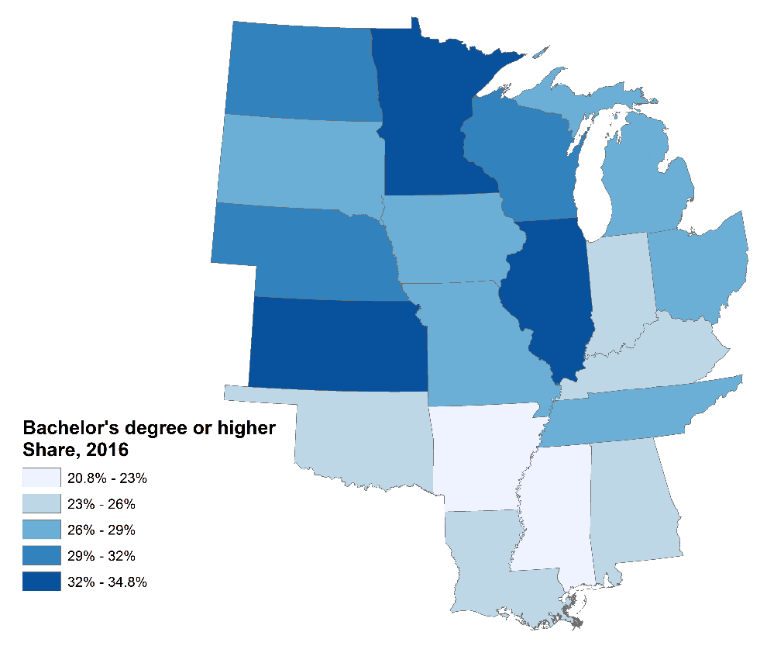
Source: Brookings analysis of 2016 ACS 1-year estimates
Name | Share of adults with a BA or higher, 2016 | Share change, 2010-16
Iowa | 28.4% | 3.5%
Illinois | 34.0% | 3.2%
Wisconsin | 29.5% | 3.2%
Michigan | 28.3% | 3.1%
Tennessee | 26.1% | 3.0%
Minnesota | 34.8% | 3.0%
Kansas | 32.8% | 3.0%
Indiana | 25.6% | 2.9%
Ohio | 27.5% | 2.9%
Kentucky | 23.4% | 2.9%
Missouri | 28.5% | 2.9%
Arkansas | 22.4% | 2.9%
Alabama | 24.7% | 2.8%
Nebraska | 31.4% | 2.8%
South Dakota | 28.9% | 2.6%
Oklahoma | 25.2% | 2.3%
Mississippi | 21.8% | 2.3%
North Dakota | 29.6% | 2.0%
Louisiana | 23.4% | 2.0%
Heartland | 28.1% | 2.9%
Non-Heartland | 32.6% | 3.1%
Source: Brookings analysis of 2016 ACS 1-year estimates

Racial bachelor’s degree gap
Compounding the region’s college attainment challenges are troubling racial gaps, which find black and Hispanic attainment lagging white and Asian attainment. These gaps diminish the skills the region can bring to bear even as they perpetuate racial income and wealth gaps.
In 2016 the gap between white bachelor’s degree attainment and black and Hispanic attainment was smaller in the Heartland than in the rest of the country, but that was driven largely by lower white bachelor’s degree attainment in the region. The attainment gap between white and black Heartland residents was 12.4 percent, compared to 15.4 percent in the rest of the country, while the gap between white and Hispanic residents in the Heartland was 15.1 percent, compared to 22.4 percent in the rest of the United States.
Black and Hispanic bachelor’s degree attainment trailed white and Asian levels in every Heartland state. The attainment gap between white and black residents was smallest in Tennessee at 7.9 percentage points, and largest in North Dakota at 21.4 percentage points. The white-Hispanic attainment gap, likewise, was smallest in Kentucky at 3.2 percentage points, and largest in Illinois at 23.3 percentage points. Conversely, Asian bachelor’s degree attainment surpassed white bachelor’s degree attainment in every Heartland state, with the largest advantage in Michigan at 33.6 percentage points, and the smallest in Minnesota at 5.3 percentage points.

Name | Share of white adults with a BA or higher, 2016 | Share of black adults with a BA or higher, 2016 |  | Share of Hispanic adults with a BA or higher, 2016 | Share of Asian adults with a BA or higher, 2016
Nebraska | 33.6% | 23.3% |  | 10.8% | 42.4%
Illinois | 37.8% | 21.6% |  | 14.5% | 65.1%
Minnesota | 36.4% | 20.7% |  | 15.2% | 41.7%
Kansas | 35.2% | 20.4% |  | 13.9% | 50.8%
Iowa | 28.8% | 19.9% |  | 12.4% | 52.6%
Tennessee | 27.3% | 19.4% |  | 14.9% | 55.1%
Oklahoma | 27.5% | 19.2% |  | 11.5% | 43.7%
Missouri | 29.5% | 18.3% |  | 19.4% | 59.0%
Alabama | 27.3% | 17.6% |  | 13.0% | 48.5%
Michigan | 29.4% | 17.0% |  | 17.5% | 63.0%
South Dakota | 30.9% | 16.8% |  | 16.9% | 41.9%
Ohio | 28.6% | 16.2% |  | 19.7% | 59.2%
Arkansas | 24.0% | 16.0% |  | 9.6% | 47.3%
Indiana | 26.8% | 15.7% |  | 13.3% | 53.5%
Mississippi | 25.5% | 15.2% |  | 12.8% | 43.1%
Wisconsin | 30.8% | 15.1% |  | 14.7% | 48.2%
Louisiana | 27.5% | 14.8% |  | 16.5% | 43.1%
Kentucky | 23.9% | 14.5% |  | 20.7% | 51.7%
North Dakota | 31.0% | 9.6% |  | 15.3% | 46.7%
Heartland | 29.9% | 17.5% |  | 14.8% | 56.0%
Non-Heartland | 37.8% | 22.4% |  | 15.4% | 52.7%
Source: Brookings analysis of 2016 ACS 1-year estimates

Adult obesity
In addition to bringing an array of health consequences, obesity negatively impacts worker and firm productivity, resulting in significant economic costs. Obesity also undercuts economic inclusion, as its burdens fall disproportionately on low-income populations, exacerbating inequality.
Heartland states face a challenge, then, given their relatively elevated and growing levels of adult obesity. The Heartland’s 32.5 percent adult obesity rate in 2016 was significantly higher than the 28.2 percent rate in the rest of the country. And while adult obesity rates across the country have increased since 2011, the Heartland’s increase of 2.8 percentage points since 2011 outpaced the 1.8 percentage point increase in the rest of the U.S.
On the state-by-state level, only one Heartland state, Minnesota, had an adult obesity rate lower than the non-Heartland average in 2016. Its 27.8 percent rate was in fact the 18th lowest in the country. Mississippi’s 37.3 percent adult obesity rate, meanwhile, led the Heartland and was the second highest in the U.S. Following Mississippi on this measure were Alabama and Arkansas, which each contend with obesity rates of 35.7 percent. All in, eight Heartland states ranked in the top 10 nationwide for highest adult obesity rate.
In terms of change over time, every Heartland state saw an increase in its adult obesity rate between 2010 and 2016. Michigan had the smallest increase in the Heartland, and 12th smallest in the U.S., at 1.2 percentage points. Tennessee, meanwhile, saw the largest increase, with its adult obesity rate increasing by 5.6 percentage points. Arkansas, Illinois, and North Dakota all also had increases in the top five nationwide, each with an increase of more than 4 percentage points from 2010 to 2016.

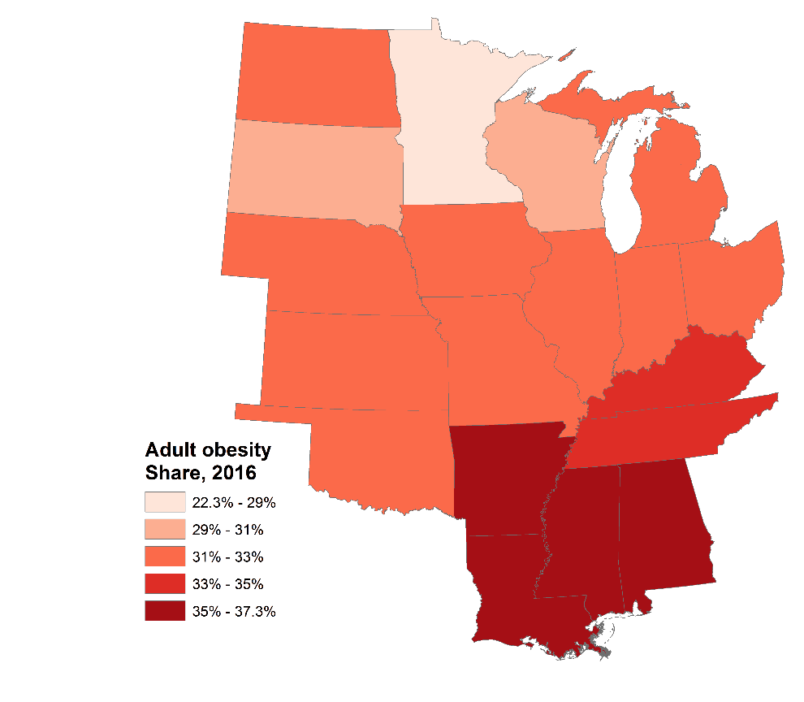
Source: Brookings analysis of CDC data

Opioid prescription rate
Opioids take a considerable toll on the U.S. economy by reducing earnings and productivity and increasing social costs. Fortunately, the rate of opioid prescriptions has begun to decline across the country. Nonetheless, there remains significantly more work to do to alleviate a crisis that is taking an immense toll on both an economic and human level.
Many states throughout the country are grappling with the impact of the opioid crisis, but Heartland states have been affected harder on average. In 2016 there were 81 opioid prescriptions for every 100 people, compared to a non-Heartland rate of 60.2 prescriptions for every 100 people. Opioid prescriptions are declining in both the Heartland and the rest of the country, but the Heartland’s annual 2.9 percent decline in opioid prescriptions has not kept pace with the 3.4 percent decline in the rest of the country.
The Heartland, and the southern Heartland in particular, was the largest source of opioid prescriptions in the United States. In 2016, the seven states with the highest opioid prescription rates were all located in the southern Heartland, and four had prescribing rates higher than their population. Alabama had the highest rate in the country, at 121 prescriptions per 100 residents, followed by Arkansas, Tennessee, and Mississippi, all of which had more than 105 prescriptions per 100 residents. Minnesota had the lowest rate in the Heartland, and fifth lowest in the nation, at 46.9.
Some progress is being made to reduce the number of opioid prescriptions issued. From 2010 to 2016, every Heartland state except for two reduced its opioid prescription rate, led by Kentucky, which saw a 5.5 percent annual decline in prescription rates, the third largest in the U.S. Kentucky was followed by Ohio and North Dakota, which had declines of 5 percent and 4.5 percent, respectively. Unfortunately, Iowa and South Dakota saw upticks in their opioid prescription rate of 0.4 percent and 0.2 percent annually.

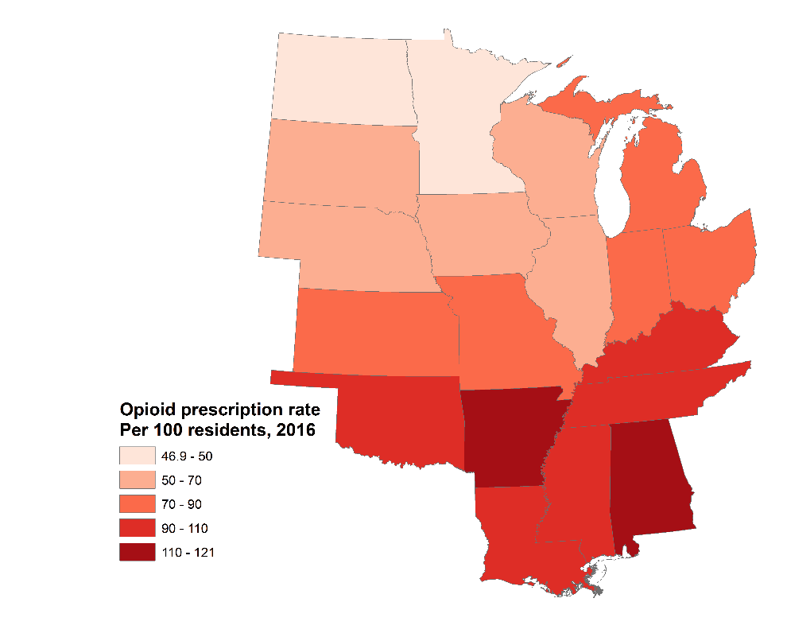
Source: Brookings analysis of CDC data

Sub-section facing page

Innovation
Indices from the factbook also show the Heartland faces shortcomings in the innovation assets and capacities needed for true vibrancy.
Notwithstanding progress on several measures, key indicators underscore that the Heartland trails the rest of the country in both overall R&D and business R&D as a share of the region’s economy.
To be sure, several states excel, including Wisconsin for overall R&D, and Michigan for business R&D. However, the region as a whole lags on R&D, in part due to the insufficient number of its research universities that are top-flight sources of commercial impact. Only 25 of the top 100 universities for technology transfer are located in the Heartland, and 11 of those are located in just three states: Illinois, Ohio, and Louisiana. That means only 14 such institutions operate in the other 16 states.
When it comes to the funding of new startups and innovations, meanwhile, the region also struggles. The Heartland received just 5.2 percent of the nation’s venture capital, half of which was captured by Illinois alone.
While the Heartland has as many large metropolitan areas as would be expected given its share of the country’s population, the region’s metro areas—necessary centers for innovation—have seen slower growth and an overall lower standard of living than in the rest of the country.
All of this comes at a particularly critical time for the region. To capture the benefits of an increasingly digital economy, the region will need to bolster its innovation ecosystem and participate more deeply.

R&D spending
R&D is an important source of the innovation that drives growth and prosperity. R&D creates intellectual property that can be converted to private sector business opportunities and commercialized by existing businesses or start-up enterprises.
Yet, just 21 percent of the nation’s R&D takes place in Heartland states, a share substantially below the region’s 28 percent share of national GDP. In 2015, in this regard, R&D accounted for just 2 percent of the Heartland’s GDP, compared to 2.7 percent elsewhere in the country. Business R&D, moreover, which is a major source of applied research and development, accounted for just 1.7 percent of the Heartland’s GDP, versus 2.4 percent of GDP in non-Heartland states.
Michigan leads the Heartland in R&D investment as a share of GDP, at 4.2 percent, ranking sixth nationally. In terms of business R&D, firms in Michigan invested 4.3 percent of private sector GDP the third highest share nationwide, and the most in the Heartland. This investment was driven by an extensive base in advanced manufacturing coupled with the presence of strong research universities. Meanwhile, several states in the southern Heartland lag. Louisiana had the lowest R&D share of GDP in the country at 0.5 percent, and Arkansas had the second lowest, also at 0.5 percent. In terms of private sector R&D, Louisiana had the lowest share in the Heartland, and the third lowest in the U.S., at 0.2 percent.
In terms of growth, however, Kansas and Michigan both managed to grow their volume of R&D expenditures by 4.5 percent annually between 2010 and 2015—the fifth and sixth fastest nationwide. Missouri, where R&D’s share of GSP is the second highest in the Heartland, rounded out the bottom of the growth ranking: R&D expenditures contracted at an annual rate of -5.9 percent over those five years. South Dakota, North Dakota, and Louisiana also saw contractions in excess of 1.0 percent. Overall, the Heartland’s 0.9 percent annual R&D growth compares poorly with the 3.2 percent rate in the rest of the country.

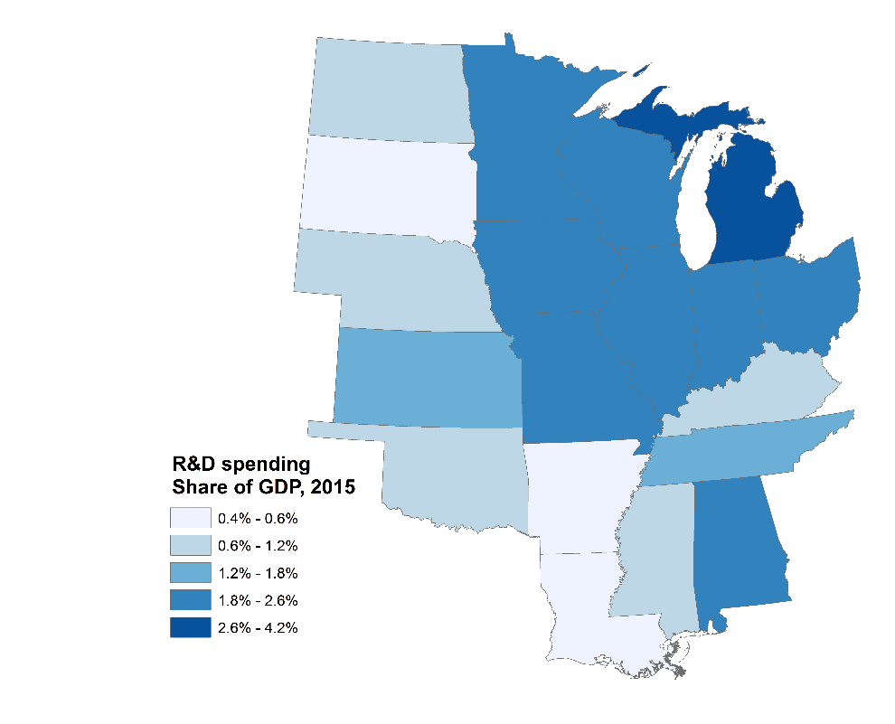
Source: Brookings analysis of NSF data
Name | R&D expenditures, ($ths) 2015 | Share of GDP, 2015 | CAGR, 2010-15
Kansas | $2,751 | 1.8% | 4.5%
Michigan | $20,145 | 4.2% | 4.5%
Oklahoma | $1,328 | 0.7% | 3.2%
Kentucky | $1,877 | 1.0% | 2.6%
Iowa | $3,451 | 1.9% | 2.5%
Ohio | $12,389 | 2.0% | 2.3%
Indiana | $7,761 | 2.3% | 2.1%
Nebraska | $1,101 | 1.0% | 1.3%
Wisconsin | $6,210 | 2.0% | 1.1%
Alabama | $4,249 | 2.1% | 0.6%
Tennessee | $4,425 | 1.4% | 0.3%
Mississippi | $955 | 0.9% | 0.3%
Minnesota | $8,156 | 2.5% | 0.0%
Arkansas | $632 | 0.5% | -0.7%
Illinois | $16,713 | 2.1% | -0.8%
South Dakota | $274 | 0.6% | -1.7%
North Dakota | $466 | 0.8% | -2.0%
Louisiana | $1,138 | 0.5% | -3.0%
Missouri | $7,521 | 2.5% | -5.9%
Heartland | $101,542 | 2.0% | 0.9%
Non-Heartland | $373,325 | 2.9% | 3.2%
Source: Brookings analysis of NSF data

University technology transfer rankings
Research universities are a major asset for states and metropolitan areas. They not only serve as talent sources and hubs, but they also convert research into intellectual property that can potentially be commercialized. This process, known as technology transfer, generates new product and industry innovations that improve worker productivity, thereby growing wages and improving the standard of living in an economy.
Unfortunately, the Heartland lags the rest of the nation in university technology transfer and commercialization.
Of the top 100 universities for technology transfer, only 25 are located in the Heartland. This is fewer than the region needs to be competitive, given that the Heartland possesses 30 percent of the U.S. population.
Illinois and Ohio lead the Heartland with four universities each ranked in the top 100 for technology transfer. Louisiana follows with three such institutions. Conversely, six Heartland states lack any university ranked in the top 100 for tech transfer. These include Alabama, Kansas, Mississippi, North Dakota, Oklahoma, and South Dakota.

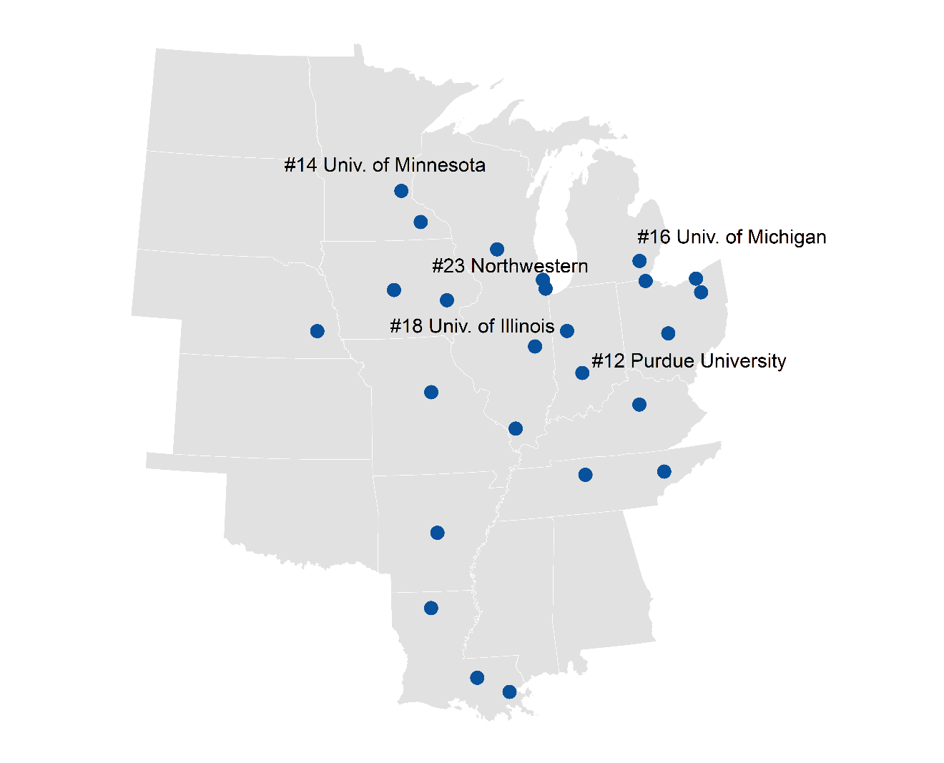
Source: Ross DeVol, Joe Lee, and Minoli Ratnatunga, “Concept to Commercialization: The Best Universities for Technology Transfer” (Santa Monica, Calif.: Milken Institute, 2017)

Venture capital spending
Venture capital (VC) and other early-stage financing fuels the startup activity that is essential to maintaining the vibrant entrepreneurial and high-tech ecosystems key to prosperity. VC is essential to new-firm formation and innovation, as it provides startups with the large, multi-year financial commitments that are necessary to develop the intellectual property into feasible products and services.
Given that, the fact that in 2017 the Heartland captured just $3.8 billion in VC funding out of a total national market of $74.1 billion is a serious problem for firms, states, and local economies in the Heartland.
That the Heartland’s share of national venture capital funding has shrunk from 11 percent to a mere 5.2 percent since 1995 accentuates the problem. As the VC market concentrates increasingly on a few coastal technology states, the Heartland has been left out—a dynamic that in truth affects virtually all states without one of the coastal superstar tech hub cities.
The story becomes even starker on the state and local level. Illinois captures half of the Heartland’s venture capital, $1.9 billion, with Chicago as a major draw for investors. Minnesota places second in the Heartland with $537 billion, mostly centered in the Minneapolis-Saint Paul metro area. In terms of growth, Nebraska led the Heartland, and placed second nationwide, with 26 percent annual growth from 1995 to 2017. Indiana, which ranked eighth in the U.S. with an annual growth rate of 13 percent during that time, followed. With that said, most Heartland states have seen flat or declining shares of national venture capital investment both since 1995 and since 2010. Oklahoma, for example, has seen its venture capital market crater, shrinking 10 percent per year from $6.1 million in 1995 to just $600,000 in 2017.

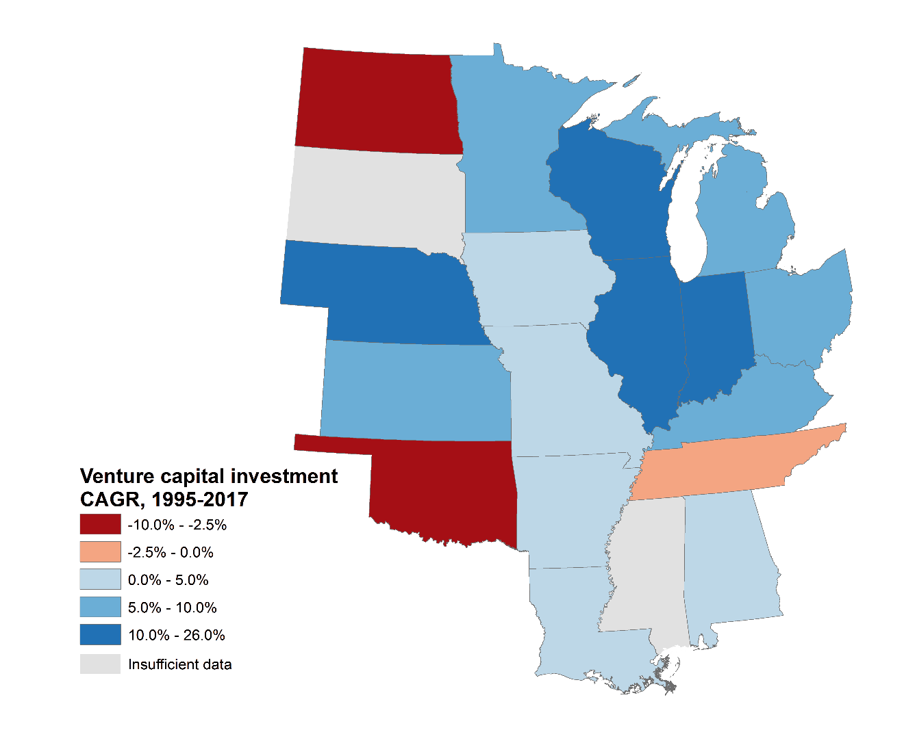
Source: Brookings analysis of PwC/CB Insights data
Sidebar

Indexing the Heartland’s position in the innovation economy
Recent research from the Walton Family Foundation adds a comprehensive overall view to the factbook’s measures of the region’s readiness to compete on innovation. Entitled “The American Heartland’s Position in the Innovation Economy,” the Walton report benchmarks the 19 Heartland states on some 107 individual metrics arrayed across five sub-categories and adds additional heft to the conclusions of the factbook.
Specifically, the new benchmarking finds that the average rank of the 19 Heartland states was 32.5 among the 50 compared to the higher 21.2 average rank of non-Heartland states. Put another way, the average Heartland state sits about seven positions below the national mean on the Walton ranking of states’ readiness to compete on the basis of R&D inputs, risk capital and entrepreneurial infrastructure, human capital investment, technology and science workforce, and technology concentration and dynamism. In short, the Heartland has work to do to participate more fully in the innovation-driven economy of the 21st century.
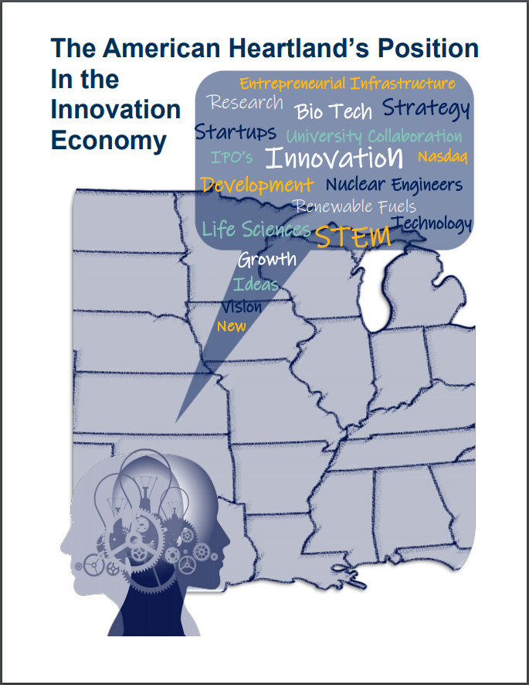

With that said, the Walton analysis reveals a number of exemplary performances among Heartland states, as well as some deeper problems. For example, the seventh highest-rated state in the nation on the analysis, Minnesota, has emerged as a national innovation star, thanks to a five-position improvement since 2014. Likewise, Illinois (16th), Michigan (18th), Wisconsin (22nd), and Nebraska (25th) all reside in the top half states—and all showed solid improvement in recent years.
TK: Create map displaying state-by-state “overall” scores?
TK: Create table displaying in our format “overall” scores and ranks?
Of course, the Heartland aggregate also obscures a stark north-south divide. The average rank of the 12 states in the northern section is 25.5 whereas the average rank for the seven southern states is 44.4. Four southern Heartland states (Louisiana, 46th; Kentucky, 47th; Mississippi, 48th; and Arkansas, 49th) plus Oklahoma remain stuck in the bottom 10 states.

Metropolitan area economic activity
Cities and their surrounding metropolitan areas are core drivers of the economy. With their higher productivity, metro areas multiply the economic yield of the economy, in part because they are hubs for the most innovative and well-educated workers. As a result, metropolitan-led growth will be important for the future economic well-being of the Heartland.
What is the Heartland’s standing on metro growth and productivity? While the Heartland has a more rural tilt than the rest of the nation, the region, in fact, has as many large metropolitan areas as would be expected given its share of the national population. Of the 53 metropolitan areas in the United States with more than 1 million people, 17 of them, or 32 percent of them, lie in the Heartland. These 17 large metropolitans are scattered across 12 states. Ohio has the most with 3, while Tennessee, Missouri, and Michigan all have 2.
Large metropolitan areas in the Heartland have lower productivity than those in the rest of the country, however. In 2016, the per job GDP in large metro areas in the Heartland was $124,000, compared to $145,000 for large metro areas elsewhere. Among the Heartland’s large metro areas, Chicago had the highest per job GDP in 2016, at $136,000. From 2010 to 2016, per job GDP in large metros in the Heartland saw little growth, increasing by an annual rate of just 0.06 percent, the same productivity growth rate as non-Heartland large metros. The Louisville metropolitan area had the fastest per job GDP growth among large Heartland metros, growing at 1 percent annually.
In terms of the region’s middle-sized metropolitan areas, containing between 250,000 and 1 million people, Clarkesville, TN-KY, bolstered by clusters in manufacturing and health care, led the Heartland with a per job GDP of $147,000 in 2016. Other top performers also had specific clusters or innovation assets, such as Baton Rouge, LA’s major research university presence, Cedar Rapids, IA’s focus on agribusiness and aerospace, and Tulsa, OK’s clusters aerospace, energy, and manufacturing. Each of these metros has a per job GDP above $125,000. Meanwhile, Flint, MI has begun to recover after being hard hit by decades of deindustrialization. It posted the fastest productivity growth of any mid-sized metro in the Heartland from 2010-2016, at 1.9 percent annual growth.
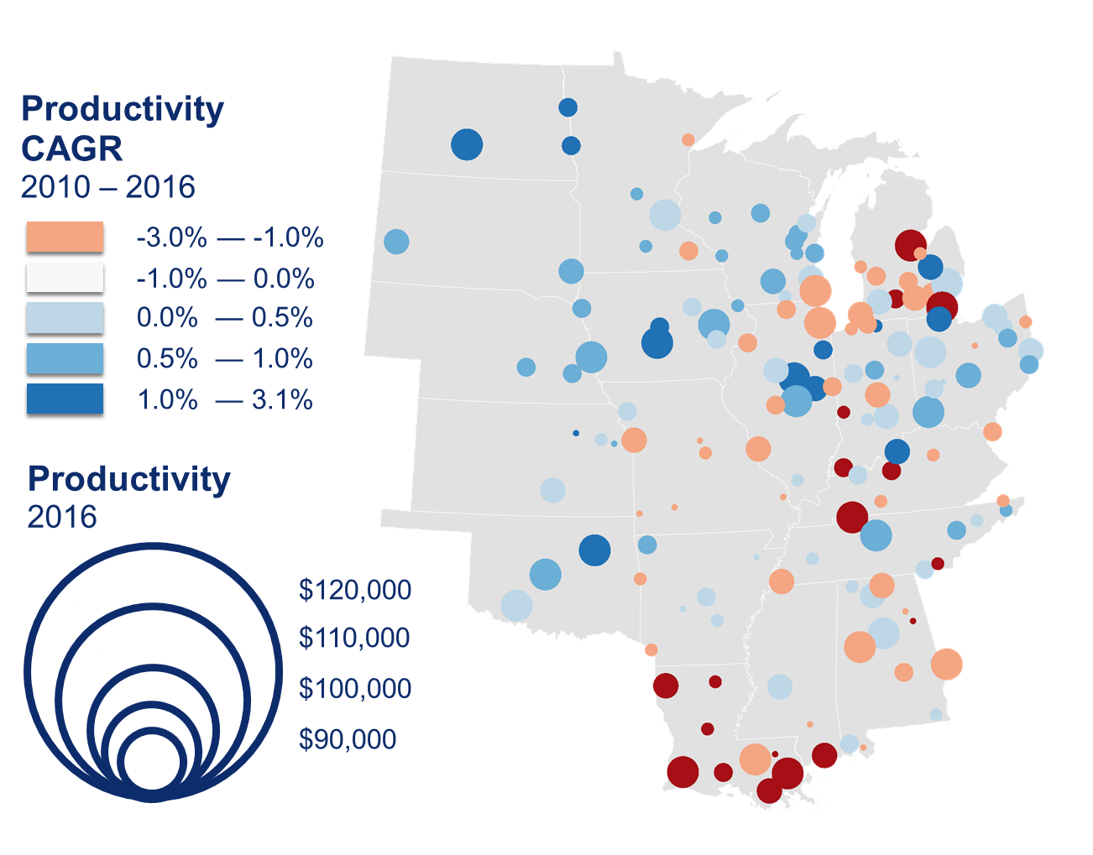
Source: Brookings analysis of Emsi and QCEW data

Sidebar

Small metro and micropolitan areas
Since 2010 smaller metropolitan and non-metropolitan areas have lost significant economic ground to larger communities. This has not been welcome news for the Heartland, as on balance the region is less urban than the rest of the country, with a greater proportion of its population living in small metro areas (with more than 50,000 people but fewer than 250,000), “micropolitan” areas (with 10,000 to 50,000 people), and non-metropolitan areas.
And yet, while the Heartland’s 384 small metropolitan and micropolitan areas tend to have lower output than larger areas, significant variation prevails. What’s more, many smaller communities have actually shown strong economic performance in recent years, outperforming not only their non-Heartland counterparts, but also many larger areas across the country.
Some of these communities have parlayed a specific industry into successful growth. For example, the recreational vehicle industry has turned Elkhart-Goshen, Ind. into the fastest-growing small metro area in the United States. Likewise, energy has driven high per capita GDP in fossil fuel-rich micropolitan areas such as Williston, N.D. and Dickinson, N.D., as well as small metropolitan refining centers like Lake Charles, La.
With that said, though, other communities have succeeded in growing faster than the nation by working proactively to establish growth strategies focused on knowledge assets, local know-how, and emerging advanced industry clusters. Five such “micropolitan success stories” were highlighted earlier this year by the Walton Family Foundation and demonstrate the potential of Heartland places and leadership. Among these communities is Oxford, Miss., which has leveraged the presence of the University of Mississippi to facilitate both a well-educated workforce and a pipeline of new firms. This has helped turn it into the 22nd-fastest growing micropolitan community in the Heartland. Meanwhile, Jasper, Ind. stands out for its strategic economic and workforce development programs. These programs include investments in “smart” infrastructure like a fiber optics buildout, as well as conditional tax credits to increase worker training, which are contingent on new job creation. Other “micropolitan success stories” include Findlay, Okla.; Brookings, S.D.; and Ardmore, Okla.

[insert stock photo of either Oxford, MI, e.g. University of Mississippi or Oxford City Hall, or Jasper, IN, e.g. county courthouse or riverfront]

Sub section title page

Infrastructure
The factbook’s indices show that while some of the Heartland’s infrastructure assets are conducive to economic growth and inclusion, several important gaps still remain.
Large communities’ agglomeration economies give them significant advantages over smaller communities, and since the end of the Great Recession, these advantages have been reflected in large metro areas’ faster growth relative to their smaller counterparts. Given this, the Heartland’s more rural character relative to the rest of the country may well be contributing to its slower population and output growth in recent years.
Housing values in the region, meanwhile, are significantly lower than in the rest of the country and are growing at a slower rate. This enables families to become homeowners with greater ease, but also makes it more difficult for middle-class families to build home equity-based wealth.
And then there is broadband access. Broadband internet access is perhaps the most critical infrastructure component for linking Americans to the modern digital economy. However, the more rural nature of the Heartland means that Heartland residents lack access to high-speed broadband at nearly twice the rate as in the rest of the country. Several Heartland states, including Wisconsin, South Dakota, Minnesota, and Kansas, have achieved near-universal broadband coverage, but there remain large access gaps across the region.

Growth by community type
The distribution of population and development across space has an under-recognized but dramatic influence on economic outcomes. Since the Great Recession, for example, populous large-metro counties have seen significantly faster population, employment, and output growth, both in the Heartland and throughout the United States, while their less populous counterparts experienced slower growth, which declined in direct relationship to county population.
These trends bear watching. Compared to the rest of the United States, the Heartland is significantly less urban and considerably more small-town and rural. In 2017, for example, 75.5 percent of the Heartland lived in a small, medium, or large metropolitan area, while 24.6 percent lived in a “micropolitan” or rural area. In non-Heartland states, by contrast, 90.4 percent of individuals lived in a metropolitan area, while only 9.6 percent lived in a micropolitan or rural area. The Heartland’s ruralness may in itself be a drag on growth.
But beyond that, population growth is occurring at slower rates across all types of communities in the Heartland. Large metro areas, or metro areas with 1 million or more people, in the Heartland, have only grown by 0.5 percent in the Heartland since 2010, but they have grown by 1.1 percent in the rest of the nation. A similar story plays out with medium-sized and small metro areas, which have grown by just 0.5 percent and 0.3 percent, respectively, in the Heartland, but by a stronger 0.9 percent and 0.5 percent, respectively, elsewhere. Meanwhile, micropolitan and rural areas in the Heartland have each lost population since 2010, with rural areas that aren’t adjacent to cities shrinking by 0.4 percent per year in the Heartland. Outside of the Heartland, such counties have shrunk at a slower 0.2 percent per year.
Finally, from 2010 to 2017 most Heartland states saw a divergence in population growth between metropolitan areas and non-metropolitan areas. A notable exception was North Dakota. Although North Dakota did see 2 percent growth in metropolitan areas, it saw slightly faster 2.1 percent growth in micropolitan areas, and also saw 1.1 percent growth in rural areas that weren’t adjacent to metro areas. This was driven in large part by the oil and gas boom that has mostly been centered on rural areas and small towns.

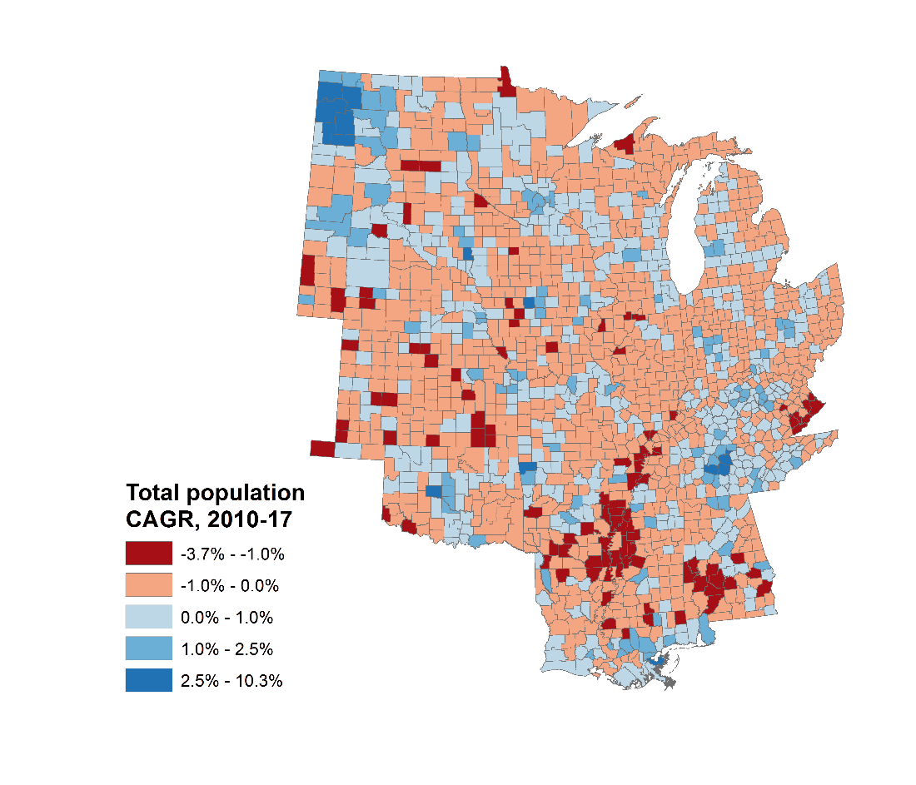
Source: Brookings analysis of Census-PEP data

Housing values
Housing is an important driver of economic prosperity for both individuals and places. Lower housing values make homeownership more affordable for the middle class, bolstering households’ disposable income and boosting consumer spending in other sectors. Lower housing values can also help cities, states, and regions attract in-migration from higher cost areas. However, places face a balancing act, as property values that are too low make it difficult for homeowners to build wealth.
In the Heartland, home values are significantly lower than in the rest of the country. When adjusted for purchasing power, the median property value in the Heartland was $133,000 in 2016, compared to $198,000 elsewhere in the U.S. Furthermore, property values have shown little growth in the heartland when adjusted for purchasing power, widening the gap between the Heartland and the rest of the country. From 2010 to 2016, purchasing power-adjusted home values increased by an annual rate of 0.2 percent in the Heartland, and 1.5 percent in non-Heartland states.
Heartland states are overwhelmingly clustered in the bottom half of the national distribution for housing values. Minnesota, ranked 22nd in the country, is the only Heartland state with a median property value in the top half of the national distribution. Its purchasing power-adjusted median property value of $195,000 is less than half of California, the leading state in the contiguous U.S. Meanwhile, Heartland states make up nine of the 10, and 15 of the 17, states with the lowest property values. Mississippi had the lowest property values in the country in 2016, with a purchasing power-adjusted median value of $102,000. Arkansas and Oklahoma were also among the lowest ranking, both with purchasing power-adjusted median housing values below $120,000.
When it comes to growth in home values, a different pattern emerges. Heartland states have shown a wide variance in home value growth, without strong regional patterns. When adjusted for purchasing power, North Dakota had far and away the fastest home value growth in the country between 2010 and 2016, growing at 5.3 percent annually. South Dakota also placed in the top ten, growing at a 2 percent annual clip after adjusting for purchasing power. Illinois, meanwhile, saw the largest decline in purchasing power-adjusted property values in the Heartland, declining at an annual rate of 2 percent from 2010 to 2016.

Name | Real median home value, 2016 | CAGR,  2010-16
North Dakota | $165,000 | 5.3%
South Dakota | $144,000 | 2.0%
Michigan | $132,000 | 1.4%
Oklahoma | $119,000 | 1.3%
Nebraska | $133,000 | 0.9%
Arkansas | $111,000 | 0.9%
Iowa | $128,000 | 0.8%
Louisiana | $142,000 | 0.7%
Kansas | $130,000 | 0.6%
Mississippi | $102,000 | 0.6%
Tennessee | $142,000 | 0.5%
Kentucky | $122,000 | 0.2%
Alabama | $122,000 | 0.0%
Indiana | $121,000 | -0.1%
Minnesota | $190,000 | -0.2%
Missouri | $136,000 | -0.2%
Ohio | $126,000 | -0.9%
Wisconsin | $155,000 | -1.2%
Illinois | $167,000 | -2.0%
Heartland | $135,000 | 0.2%
Non-Heartland | $215,000 | 1.5%
Source: Brookings analysis of 2010 & 2016 ACS 1-year estimates

Broadband access
The internet has become essential to American life. Today the internet is used by workers telecommuting to jobs, firms selling products to customers, and students conducting research and learning through digital classrooms. Furthermore, broadband deployment drives growth in both output and employment, with particularly significant impacts in rural areas. Unfortunately, there are broad inequities in access to high-speed broadband.
Relative to population, nearly twice as many people lack high-speed broadband access in the Heartland compared to the rest of the country. In the Heartland, 6.6 percent of residents do not have high-speed broadband access, compared to 3.4 percent in non-Heartland states. This equates to nearly 6.5 million people in the Heartland without access to high-speed broadband, compared to 7.7 million people elsewhere.
There is wide variation in state-level high-speed broadband access. Mississippi makes do with the third-highest population share without access in the country, and the highest disconnected share in the Heartland, with 17.2 percent of residents lacking access. Arkansas, Alabama, Indiana, and South Dakota also rank among the 10 highest nationally, each with rates of 11.5 percent or higher. On the other hand, several Heartland states have achieved universal or near-universal high-speed broadband access. In Iowa less than 1 percent of residents lack access to high-speed broadband. In two other Heartland states, Minnesota, and Illinois, less than 2 percent of residents lack access.

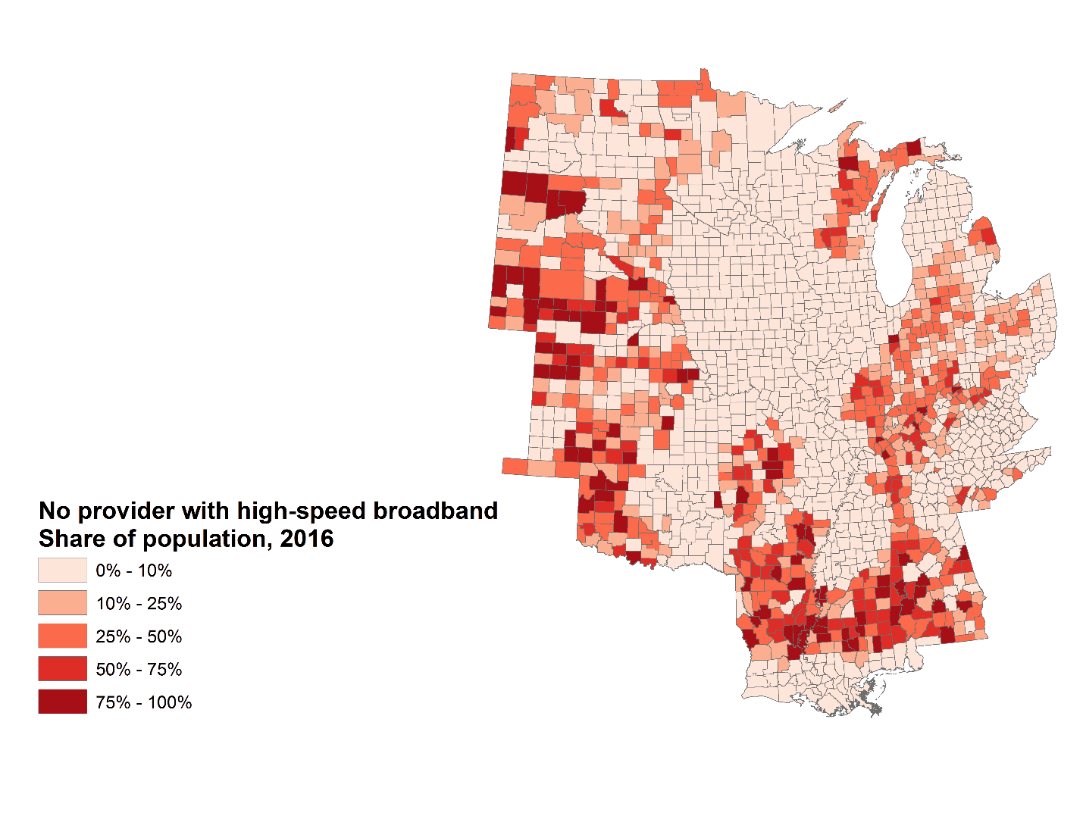
Source: Brookings analysis of FCC data

The state of the Heartland: benchmarking outcomes and drivers
Outcomes | Current |  | Change
 | Heartland | Non-Heartland | Heartland | Non-Heartland
Growth
Jobs | 44,378,000 | 99,483,000 | 1.3% | 1.9%
Output (Mil.) | $4,905,000 | $12,802,000 | 1.4% | 1.9%
Jobs at young firms | 3,297,000 | 9,341,000 | -0.3% | 0.4%
Prosperity
Productivity | $111,000 | $131,000 | 0.1% | 0.0%
Average wage | $48,000 | $49,000 | 1.0% | 0.8%
Standard of living | $50,000 | $57,000 | 1.1% | 0.9%
Inclusion
Employment rate | 72.8% | 72.4% | 3.2% | 3.4%
Median wage | $30,000 | $28,000 | 0.6% | -0.4%
Poverty rate | 14.6% | 13.8% | -1.2% | -1.3%
Drivers | Current |  | Change
 | Heartland | Non-Heartland | Heartland | Non-Heartland
Tradeable Industries
Adv. industries (employment share) | 9.8% | 9.5% | 2.5% | 0.6%
Exports (share of GDP) | 12.3% | 9.6% | 1.8% | 2.3%
Agriculture (output) | $225,609,000 | $187,628,000 | 1.2% | 0.5%
Energy (bn BTU) | 21,300 | 47,700 | 2.0% | 2.6%
Human Capital
Population | 98,828,000 | 226,891,000 | 0.3% | 0.9%
Young adult population | 21,998,000 | 49,870,000 | 0.4% | 1.2%
Bachelor's degree attainment | 28.1% | 32.6% | 2.9% | 3.1%
Racial degree gap (black-white attainment gap) | 58.5% | 59.3% | N/A | N/A
Adult obesity | 32.5% | 28.2% | 2.8% | 1.8%
Opioid prescription rate (per 100 residents) | 81.0 | 60.2 | -2.9% | -3.4%
Innovation
R&D spending (% of GDP) | 2.0% | 2.9% | 0.9% | 3.2%
University tech transfer rankings | 25 | 75 | N/A | N/A
Venture capital spending (% of total) | 5.2% | 94.8% | -5.8% | 5.9%
Metro area econ activity (large metro) | $124,000 | $145,000 | 0.1% | 0.1%
Infrastructure
Growth by community (large metros) | 75.4% | 90.4% | 2.0% | 0.8%
Housing values | $135,000 | $215,000 | 0.2% | 1.5%
Broadband access (% without) | 6.6% | 3.4% | N/A | N/A
Source: Brookings Institution / Walton Family Foundation ”The State of the Heartland: Factbook 2018”
Note: Blue and red shading indicates positive or negative distance from the non-Heartland average, respectively.

Takeaways

On the nation’s coasts, the red-blue, rural-urban divide has solidified into a truism of American politics.
One party is now the party of coastal, dense, urban America, write commentators as diverse as Ron Brownstein, Charles Lane, and Will Wilkinson. The other party, meanwhile, dominates “flyover country” and the other places—the nation’s small towns, its rural areas, its agricultural hinterlands.
In keeping with that, the Heartland and its economy are now increasingly seen through a partisan lens—a lens that can be both limiting and self-fulfilling.
In the face of that, this “State of the Heartland” factbook has sought to help the Heartland see itself through its own, more accurate and factual, mirror. In that way it is hoped that the factbook will help leaders and changemakers from all across the region develop a clearer vision as they move to widen the circle of prosperity.
What do the indices say about the region? Primarily, the factbook’s economic measures confirm that the Heartland is not only distinctive—different from the rest of the country—but that it is doing better in many areas than is sometimes portrayed (particularly by those elsewhere).
- Job growth and output growth have been steady, if not stellar.

- The median wage is increasing, and in fact exceeds that in the rest of the country, particularly because of the lower cost of living, including cheaper housing.

- Poverty is decreasing across the region since the start of the recovery.

Supporting all of this, meanwhile, is an impressive base of export industries, in particular strong concentrations of advanced manufacturing in the eastern Heartland and globally significant agriculture in the western Heartland. In that sense, contrary to the negative stereotype, the 19 Heartland states constitute a manufacturing super-region and an export powerhouse that outperforms that rest of the country on crucial core economic indicators.
Nor is the region homogenous. Like the country as a whole, the Heartland is a checkerboard of regions, states, and local communities—many of which are prospering even as others deteriorate. In this respect, the Heartland is more varied than the coastal meme portrays, as many Heartland places thrive while others decline.
- On multiple measures, for instance, a stark gap exists between the performance of the western Heartland and the eastern Heartland. Labor force participation, for example, remains at crisis levels in the eastern Heartland, while to the west on the Plains states’ labor markets are some of the tightest in the nation.

- Similarly, stark gaps also exist between the northern Heartland and the southern one. For example, while most northern states reside in the top half of states on measures of human capital and innovation most southern ones reside among the bottom 10.

- On other measures, particular sub-state or multi-state swaths of counties are flourishing while other swaths face acute hardships. The Plains in general are performing quite well, according to the factbook, while regions such as the Black Belt (running through Louisiana, Mississippi, and Alabama), Appalachia, and Indian Country in the Dakotas are facing an emergency of elevated poverty (shared by minorities throughout the region) and high rates of chronic conditions related to obesity. Likewise, Heartland metropolitan areas are doing better than its rural areas.

- And then, certain states have made more progress than others. On advanced industries employment Michigan has been growing rapidly while South Dakota and Oklahoma have been shedding jobs. On broadband, some states like Iowa, Minnesota, and Illinois have achieved near-universal access, while others—Mississippi, Arkansas, and Alabama—still have significant populations without and are making only slow progress.

And yet, even while factoring in both under-recognized strengths and under-recognized variation, the fact remains that unmistakable shortcomings of the region’s human capital and innovation capacity are very likely keeping the Heartland from reaching its full potential. These deficits represent the most challenging findings of the factbook and pose the most serious challenges to changemakers, in a number of ways:

- Slow population growth, including among young people, limits the region’s overall economic growth.

- Lower bachelor’s degree attainment and significant racial attainment gaps leave workers less prepared for an increasingly digitalized labor market

- Less dynamic metro areas put the region at a disadvantage, given the stronger productivity and faster growth that bigger cities been delivering since the end of the recession.

- Weak R&D flows, a thin roster of top universities for tech transfer, and a near-complete dearth of venture capital investment leave Heartland firms and industries farther removed from new ideas, new practices, and new sources of efficiency or value than those firms elsewhere.

- And finally, heart-rending epidemics of obesity and opioid use are not only sources of inordinate human suffering in the region but substantial drags on worker productivity and economic output.

In short, the factbook’s human capital and innovation indicators depict a region that is struggling to amass the fundamental human capacities that are essential to support long-term, broad-based prosperity. These measures cut against other more encouraging data and raise an alarm.

*
What do these findings suggest for future discussion and action? Above all, the data here underscore that ways to increase the region’s store of human capital and expand its innovation activities should be top-of-mind when Heartland leaders gather to talk about the region’s future.
The reason for this is clear. The human and innovation capacities of places are now the core drivers of long-term economic performance. Or as the Walton Family Foundation’s Ross DeVol notes, the states and regions that build human capacity and invest in and nurture innovation will establish ecosystems that create high-paying jobs for their citizens and attract migrants from elsewhere, boosting economic growth further.
In keeping with that, Heartland changemakers should get serious about learning from the region’s best successes in nurturing talent and catalyzing innovation as a prime way to close prosperity gaps.
DeVol’s Walton analysis points to some of the home-grown success stories that can be emulated. On the education side, Minnesota is now a national best-practice model for the fast progress it has made in increasing its B.A. attainment and developing its technology and science workforce. Arkansas, meanwhile, is one of the only states in the nation to be implementing all of Code.org’s recommended initiatives for diffusing computer science knowledge throughout K-12 education. And Nebraska’s Library Innovation Studios project is increasing the availability of makerspaces and technology tools to encourage entrepreneurship and creativity in rural areas of that state. Overall, Heartland leaders have the opportunity now to change their region’s future by making higher education more accessible and affordable (particularly in in-demand fields such as STEM or digital) even as they improve K-12 for everyone, expand models for accelerated learning, and support lifelong learning for the workforce.
Likewise, world-class models for aggressively building the region’s innovation capacity exist close at hand. Michigan is not only the top-ranked Heartland state on R&D activity but a national leader on policies and planning to enhance its future position. Ohio’s voter-approved Third Frontier program remains a powerful model for accelerating the growth of high-tech companies with marketable products through a variety of technology-development, entrepreneurship, start-up, and capitalization programs. Indiana universities are increasing their research efforts and focusing on commercialization and new-firm formation. And for that matter, Heartland states and regions have become national leaders at systematically strengthening advanced-industry clusters that amplify local innovation and entrepreneurship. Tennessee has maintained a strong focus on moving its large auto sector up the value chain with enhanced innovation efforts. Likewise, Central Indiana, Milwaukee, and St. Louis were all featured in recent Brookings research highlighting top U.S. cluster initiatives. Milwaukee’s water cluster has established the region as a top global hub for innovation and solutions to the world’s water challenges. In the St. Louis region key actors have collaborated to spur growth in the “ag tech.” As for Indiana, the Central Indiana Corporate Partnership (CICP) has innovated by configuring itself as a CEO-led “holding company” that houses six distinct economic development initiatives, including cluster initiatives such as BioCrossroads (life sciences) and AgriNovus (agricultural biosciences). Current initiatives now include the creation of the Indiana Biosciences Research Institute (IBRI) linking industry and university research interests, as well as the development of the 16Tech “innovation district” to localize innovation work in the urban core.
In short, the Heartland boasts—even in its most challenging areas of need—some of the most dynamic collaborations anywhere of business, civic, and government changemakers working together to solve problems.
And so, the Heartland’s leaders should survey it all, assess what’s working, and get to work.
Notwithstanding its many challenges, the Heartland is large, varied, and full of communities already hard at work. These places are learning what’s real, making big plans, and putting them in motion to make the Heartland better. In all of that there is surely grist for unlocking the Heartland’s full potential, and in doing so unleashing America’s.

Appendix: Methods & Measures

The “State of the Heartland: Factbook 2018” draws on a variety of public data sources from the U.S. Census Bureau and Bureau of Labor Statistics (BLS) as well as from Emsi.
Emsi provides proprietary estimates of jobs, wages, and gross product by industry that are based upon official statistics published by the Census Bureau and BLS.
In general, the factbook uses data from two Census Bureau programs: the Longititudinal Employer-Household Dynamics Program (LEHD) and the American Community Survey Public Use Microdata Series (PUMS).
Annual change is measured using the compound annual growth rate (CAGR). For indicators where the primary metric is measured in percent (e.g. employment-to-population ratio), change is reflected using percentage point change rather than CAGR.
Large metropolitan areas are defined as those having more than 1 million people, medium-sized metropolitan areas are those with between 250,000 and 1 million people, and small metro areas are those with between 50,000 and 250,000 people. Micropolitan areas are non-metropolitan areas with 10,000 to 50,000 people, and rural areas are non-metropolitan areas with fewer than 10,000 people.
Additional detail on the sourcing and methods used to develop the factbook’s individual indicators follows.
Outcomes
Growth
- Jobs
Note: Includes all employees in all industries across all ownership types

Source: Quarterly Census of Employment and Wages from the Bureau of Labor Statistics, https://www.bls.gov/cew/ (accessed March 2018)

- Output
Note: Constant 2016 dollars calculated using the March 2018 GDP Price Index from the Bureau of Economic Analysis

Source: Emsi 2017.4

- Jobs at young firms
Source: U.S. Census Bureau, Longitudinal Employer-Household Dynamics Program’s Quarterly Workforce Indicators, https://lehd.ces.census.gov/data/ (accessed July 2018)

Prosperity
- Productivity
Note: Constant 2016 dollars calculated using the March 2018 GDP Price Index from the Bureau of Economic Analysis

Sources: Bureau of Labor Statistics, Quarterly Census of Employment and Wages, https://www.bls.gov/cew/ (accessed March 2018); Emsi 2017.4

- Average wage
Notes: Constant 2009 dollars calculated using the February 2018 Personal Consumption Expenditures (PCE) Price Index, and adjustment for cost-of-living differences made using the May 2018 Regional Price Parities (RPP) by State, both from the Bureau of Economic Analysis. RPP Indices used for the Heartland and Non-Heartland regions were constructed by averaging across states, weighted by population

Sources: U.S. Bureau of Economic Analysis, “Table SA25N Total Full-Time and Part-Time Employment by NAICS Industry,” https://www.bea.gov/regional/downloadzip.cfm, (accessed March 2018); U.S. Bureau of Economic Analysis, “Table SA7N Wages and Salaries by NAICS Industry,” https://www.bea.gov/regional/downloadzip.cfm, (accessed May 2018)

- Standard of living
Note: Constant 2016 dollars calculated using the March 2018 GDP Price Index from the Bureau of Economic Analysis

Sources: Emsi 2017.4; U.S. Census Bureau, Population Estimates Program, https://www.census.gov/programs-surveys/popest/data/data-sets.html (accessed March 2018)

Inclusion
- Employment rate
Sources: U.S. Census Bureau, 2010 and 2016 American Community Survey 1-Year Estimates, Table S2301, https://factfinder.census.gov/ (accessed July 2018)

- Median wage
Notes: Constant 2009 dollars calculated using the February 2018 Personal Consumption Expenditures (PCE) Price Index, and adjustment for cost-of-living differences made using the May 2018 Regional Price Parities (RPP) by State, both from the Bureau of Economic Analysis. RPP Indices used for the Heartland and Non-Heartland regions were constructed by averaging across states, weighted by population

Sources: U.S. Census Bureau, 2010 and 2016 American Community Survey 1-Year Public Use Microdata Sample, https://www.census.gov/programs-surveys/acs/data/pums.html (accessed July 2018)

- Poverty rate
Source: U.S. Census Bureau, Small Area Income and Poverty Estimates (SAIPE) Program, https://www.census.gov/programs-surveys/saipe/data/datasets.html (accessed July 2018)

Drivers

Tradeable industries
- Advanced industries
Note: Constant 2016 dollars calculated using the March 2018 GDP Price Index provided by the Bureau of Economic Analysis

Sources: Emsi 2017.4 and 2018.2

- Exports
Source: Nick Marchio and Joseph Parilla, “Export Monitor 2018” (Washington: Brookings Institution, 2018)

- Agriculture
Note: Value of agricultural sector production in constant 2018 dollars

Source: U.S. Department of Agriculture, U.S. and State Farm Income and Wealth Statistics, https://www.ers.usda.gov/data-products/farm-income-and-wealth-statistics.aspx (accessed on May 2018)

- Energy
Source: U.S. Energy Information Administration, State Energy Data System (SEDS), https://www.eia.gov/state/seds/seds-data-complete.php?sid=US (accessed June 2018)

Human capital
- Population
Source: U.S. Census Bureau, Population Estimates Program, https://www.census.gov/programs-surveys/popest/data/data-sets.html (accessed March 2018)

- Young adult population
Sources: U.S. Census Bureau, 2010 and 2016 American Community Survey 1-Year Estimates, Table S2301, https://factfinder.census.gov/ (accessed July 2018)

- Bachelor’s degree attainment
Sources: U.S. Census Bureau, 2010 and 2016 American Community Survey 1-Year Estimates, Table S1501, https://factfinder.census.gov/ (accessed July 2018)

- Racial bachelor’s degree gap
Source: U.S. Census Bureau, 2016 American Community Survey 1-Year Estimates, Table S1501, https://factfinder.census.gov/ (accessed July 2018)

- Adult obesity
Source: Centers for Disease Control, Behavioral Risk Factor Surveillance System (BRFSS), https://www.cdc.gov/brfss/index.html (accessed May 2018)

- Opioid prescription rate
Source: Centers for Disease Control, National Center for Injury Prevention and Control, https://www.cdc.gov/drugoverdose/maps/rxrate-maps.html (accessed August 2018)

Innovation
- R&D spending
Sources: National Science Foundation, State Indicators 2018, R&D as a Percentage of Gross Domestic Product, https://www.nsf.gov/statistics/state-indicators/ (accessed May 2018); National Science Foundation, State Indicators 2018, Business-Performed R&D as a Percentage of Private-Industry Output, https://www.nsf.gov/statistics/state-indicators/ (accessed May 2018)

- University technology transfer rankings
Source: Ross DeVol, Joe Lee, and Minoli Ratnatunga, “Concept to Commercialization: The Best Universities for Technology Transfer” (Santa Monica, Calif.: Milken Institute, 2017)

- Venture capital spending
Source: PwC/CB Insights, MoneyTree Report, Regional aggregate data, https://www.pwc.com/us/en/industries/technology/moneytree.html (accessed May 2018)

- Metropolitan area economic activity
Note: Constant 2016 dollars calculated using the March 2018 GDP Price Index from the Bureau of Economic Analysis

Sources: Emsi 2017.4; Quarterly Census of Employment and Wages from the Bureau of Labor Statistics, https://www.bls.gov/cew/ (accessed March 2018)

Infrastructure
- Growth by community type
Source: U.S. Census Bureau, Population Estimates Program, https://www.census.gov/programs-surveys/popest/data/data-sets.html (accessed March 2018)

- Housing values
Note: Constant 2009 dollars calculated using the March 2018 GDP Price Index from the Bureau of Economic Analysis
Source: U.S. Census Bureau, 2010 and 2016 American Community Survey 1-Year Public Use Microdata Sample, https://www.census.gov/programs-surveys/acs/data/pums.html (accessed July 2018)

- Broadband access
Source: Federal Communications Commission, Fixed Broadband Deployment, Area Table Dec2016, https://broadbandmap.fcc.gov/#/data-download (accessed May 2018)

References
Berube, Alan, and Cecile Murray. 2018. “Renewing America’s Economic Promise through Older Industrial Cities.” Washington. Brookings Institution.
DeVol, Ross, Jonas Crews, and Shelly Wisecarver. “The American Heartland’s Position in the Innovation Economy.” Bentonville. Walton Family Foundation.
——. 2018. “Perspectives on Defining the American Heartland.” Bentonville. Walton Family Foundation.
DeVol, Ross, and Shelly Wisecarver. 2018. “Micropolitan Success Stories from the Heartland.” Bentonville. Walton Family Foundation.
Lind, Michael, and Joel Kotkin. 2017. “The New American Heartland: Renewing the Middle Class by Revitalizing Middle America.” Houston. Center for Opportunity Urbanism.
Muro, Mark, and others. 2017. “Digitalization and the American Workforce.” Washington. Brookings Institution.
——. 2015. “America’s Advanced Industries: What They Are, Where They Are, and Why They Matter.” Washington. Brookings Institution
Shearer, Richard, and others. 2018. “Metro Monitor: An Index of Inclusive Economic Growth in the 100 Largest Metropolitan Areas.” Washington. Brookings Institution.

Acknowledgments
The Brookings Institution is a nonprofit organization devoted to independent research and policy solutions. Its mission is to conduct high-quality independent research and, based on that research, to provide innovative, practical recommendations for policymakers and the public. The conclusions and recommendations of any Brookings publication are solely those of the author(s) and do not reflect the views of the institution, its management, or its other scholars.
The Metropolitan Policy Program at Brookings would like to thank Ross DeVol and the Walton Family Foundation for the generous support of this project.
The project team at Brookings would also like to thank a number of colleagues who provided input on the fact book. At the top of the list is Ross DeVol of the Walton Family Foundation, who provided important brainstorming about the concept and generous feedback on its realization. In addition, the team is grateful for help of various kinds from: Carly Anderson, Alan Berube, Alec Friedhoff, Amy Lui, Julia Kraeger, David Lanham, Rhianna Taylor and Markham Group, and Luisa Zottis.
Brookings is committed to quality, independence, and impact in all of its work. Activities supported by its donors reflect this commitment.
*
Ross DeVol would like to thank members of the Walton family—Olivia, Steuart, Jim, and Alice--who had the vision to convene the Heartland Summit. Without them, State of the Heartland: Factbook 2018 would not have been envisioned. Additionally, DeVol would like to thank Kyl Peterson, executive director of the Walton Family Foundation, for his support and guidance during the planning and execution of work related to the Heartland Summit. Thanks also go to Shelly Widecarver and Jonas Crews for embarking on the journey.

Image credits
TK
About the Metropolitan Policy Program at Brookings
The Metropolitan Policy Program at Brookings delivers research and solutions to help metropolitan leaders build an advanced economy that works for all.
To learn more visit www.brookings.edu/metro
For more information:
Mark Muro
Senior Fellow
Metropolitan Policy Program at Brookings
mmuro@brookings.edu

About the Walton Family Foundation
The Walton Family Foundation is, at its core, a family-led foundation. The children and grandchildren of our founders, Sam and Helen Walton, lead the foundation and create access to opportunity for people and communities. The foundation works in three areas: improving K-12 education, protecting rivers and oceans and the communities they support, and investing in its home region of Northwest Arkansas and the Arkansas-Mississippi Delta. In 2017 the foundation awarded more than $535 million in grants in support of these initiatives.
To learn more visit: www.waltonfamilyfoundation

Endnotes

See Mark Muro and others, “America’s Advanced Industries: What they Are, Where they Are, and Why they Matter” (Washington: Brookings Institution, 2015).
Thomas Friedman, “A Road Trip Through Rusting and Rising America.” The New York Times, May 24, 2017.
Emily Badger and Kevin Quealy, “Where Is America's Heartland? Pick Your Map.” The New York Times, January 3, 2017.
Ross DeVol, “Perspectives on Defining the American Heartland.” (Bentonville: Walton Family Foundation, 2018).
The Oxford English Dictionary. (Oxford: Oxford University Press, 2018).
The Merriam Webster Dictionary. (New York: Merriam Webster Inc, 2005).
See Chad Shearer and others, “Metro Monitor: An Index of Inclusive Economic Growth in the 100 Largest U.S. Metropolitan Areas” (Washington: Brookings Institution, 2018).
This definition of economic development reflects discussion in Maryann Feldman and others, “Economic Development: A Definition and Model for Investment (Washington: Economic Development Administration, 2016).
These drivers are drawn from the factors identified for regional prosperity by the Brookings Metropolitan Policy Program in partnership with Valley Vision, Greater Sacramento Economic Council, Sacramento Metro Chamber, Sacramento Region Business Association, and Sacramento Area Council of Governments. See Joseph Parilla, Sifan Liu, and Marek Gootman, “Charting a Course to the Sacramento Region’s Future Economic Prosperity” (Washington: Brookings Institution, 2018).
Examples of spillover effects include productivity increases in industries like Employment Services, bolstered by the number of contract workers in the energy industry, and Professional Services, which include engineering firms working on energy-related projects.
Wolfers, J., & Zilinsky, J. (2015, January 13). “Higher Wages for Low-Income Workers Lead to Higher Productivity.” Retrieved from https://piie.com/blogs/realtime-economic-issues-watch/higher-wages-low-income-workers-lead-higher-productivity
See Robert A. Moffitt, “The Reversal of the Employment-Population Ratio in the 2000s: Facts and Explanations,” Brookings Papers on Economic Activity (Fall 2012): 201-264.
Elizabeth Kneebone and Natalie Holmes, “U.S. concentrated poverty in the wake of the Great Recession” (Washington: Brookings Institution, 2016).
Black Belt is defined as Heartland counties with greater than 50 percent African American population
Appalachia is defined as Heartland counties under the purview of the Appalachian Regional Commission; for a complete list of Appalachian Regional Commission counties, see https://www.arc.gov/appalachian_region/CountiesinAppalachia.asp
See Emilia Istrate, Jonathan Rothwell, and Bruce Katz, “Export Nation: How U.S. Metros Lead National Export Growth and Boost Competitiveness” (Washington: Brookings Institution, 2008). For an analysis of the wage premium from exports, see David Riker, “Export-Intensive Industries Pay More on Average: An Update” (Department of Commerce, 2015).
See Mark Muro, Jacob Whiton, and Robert Maxim, “How China’s Proposed Tariffs Could Affect U.S. Workers and Industries (Washington: Brookings Institution, 2018) and Mark Muro and Joe Parilla, “U.S. Metros Most Exposed to A Trump Trade Shock.” (Washington: Brookings Institution, 2017).
See OECD, “Chapter 1: The Role of Agriculture in the US Economy” in “Evaluation of Agricultural Policy Reforms in the United States” (2011).
See Economic Research Service, “Ag and Food Sectors and the Economy” (Department of Agriculture, 2018), and OECD, ““Evaluation of Agricultural Policy Reforms in the United States.”
Jonas Crews and Ross Devol, “American Heartland Counties Targeted by Chinese Tariffs on U.S. Crops.” (Bentonville: Walton Family Foundation, 2018).
For a more in-depth overview of the impact of millennials on the labor force, see William H. Frey, “The millennial generation: A demographic bridge to America’s diverse future” (Washington: Brookings Institution, 2018).
See David S. Ludwig and Kenneth S. Rogoff, “The Toll of America’s Obesity,” The New York Times, August 9, 2018; see also Ross A. Hammond, “Obesity, Prevention, and Health Care Costs” (Washington Brookings Institution, 2012), and Joanna Venator and Richard V. Reeves, “Weight and social mobility: Taking the long view on childhood obesity” (Washington: Brookings Institution, 2015).
Ross DeVol, Jonas Crews, and Shelly Wisecarver, “The American Heartland’s Position In the Innovation Economy” (Bentonville, Ark.: Walton Family Foundation, 2018).
RossDeVol, Joe Lee, and Minoli Ratnatunga, “Concept to Commercialization: The Best Universities for Technology Transfer” (Santa Monica, Calif.: Milken Institute, 2017). See also Robert D. Atkinson and J. John Wu, “The 2017 State New Economy Index: Benchmarking Economic Transformation in the States” (Washington: Information Technology and Innovation Foundation, 2017).
DeVol, Crews, and Wisecarver, “The American Heartland’s Position In the Innovation Economy.”
This ranking excludes seven U.S. states that did not receive any venture capital funding in 1995.
Ross DeVol, Jonas Crews, and Shelly Wisecarver, “The American Heartland’s Position in the Innovation Economy.” (Bentonville: Walton Family Foundation, 2018).
See Alan Berube and Carey Anne Nadeau, “Metropolitan Areas and the Next Economy: A 50-State Analysis” (Washington: Brookings Institution, 2011).
See Ross DeVol and Shelly J. Wisecarver, “Micropolitan Success Stories from the Heartland” (Bentonville, Ark.: Walton Family Foundation, 2018).
See Mark Muro and Jacob Whiton, “Geographic gaps are widening while U.S. economic growth increases,” The Avenue, January 23, 2018; see also Mark Muro and Jacob Whiton, “In 2017, rural places won a little more, but will it last?” The Avenue, March 20, 2018.
Large metropolitan areas are defined as having a population of 1 million or more. Medium-sized metropolitan areas are those with a population of more than 250,000 but less than 1 million. Small metropolitan areas have more than 50,000 people, but less than 250,000. Micropolitan areas are defined as urban clusters with a population of at least 10,000 but fewer than 50,000 people. Rural areas are defined as all counties in a state that are not included in a metropolitan or micropolitan area. For additional commentary on the performance of Heartland micropolitan areas, see Ross DeVol and Shelly Wisecarver, “Micropolitan Success Stories from the Heartland” (Bentonville, Ark.: Walton Family Foundation, 2018).
See Cecile Murray and Jenny Schuetz, “Housing in the US is too expensive, too cheap, and just right. It depends on where you live.” (Washington: Brookings Institution, 2018).
See Darrell M. West, “Technology and the Innovation Economy” (Washington: Brookings Institution, 2011), and Hilal Atasoy, “The Effects of Broadband Internet Expansion on Labor Market Outcomes,” ILR Review, 66 (2) (2013): 315-345.
See Adie Tomer, Elizabeth Kneebone, and Ranjitha Shivaram, “Signs of digital distress” (Washington: Brookings Institution, 2017), and Adie Tomer, “Broadband gaps impact every member of Congress” The Avenue, November 7, 2017.
See, for example, Ron Brownstein, “America, a Year Later,” CNN, November, 2017; Charles Lane, “Red America and Blue America Depend on Each Other. That’s How It Should Be.” The Washington Post, April 23, 2018; and Will Wilkinson, “Why DO WE Value Country Folk More Than City People?” The New York Times, June 27, 2018.
DeVol, “The American Heartland’s Position in the Innovation Economy.”
Ibid.
EDC / MassCAN and others, “State of the States Landscape Report: State-Level Policies Supporting Equitable K-12 Computer Science Education.” (New York: BNY Mellon, 2017).
See, for example, “Revv! Program Supports Statewide Manufacturing Innovation” and Mark Muro and others, “Drive: Moving Tennessee’s Automotive Sector Up the Value Chain.” (Washington: Brookings Institution, 2013).
Ryan Donahue, Joseph Parilla, and Brad McDearman, “Rethinking Cluster Intiatives.” (Washington: Brookings Institution, 2018)

